**ASSIGNMENT COVER SHEET**

|  |  |  |  |  |  |  |  |  |
| --- | --- | --- | --- | --- | --- | --- | --- | --- |
| **Course: BSc Computing** | | | | **Year: 3** | | **Software Engineering 3** | | |
| Assignment No: 1 | | **Title: The Design and Development of Client-Driven Software Solution Using a Rapid Application Development/Agile Hybrid Development Methodology** | | | | | | |
| Date due out: | Date due in: March 3 | | Extension date: | | | | | Extension agreed by: |
| **Student Name: SUDISH BASNET**  **Student ID: 18413692** | | | | | | | **Tutor: Mark Johnson** | |
| Video Demo : **https://northampton.mediaspace.kaltura.com/media/Software+Engineering+3+Assignment+Demo/1_cj2y9s9j** | | | | | Marker’s General View of the work | | | |

**ASSESSMENT FEEDBACK:**

|  |  |  |  |  |  |  |  |  |
| --- | --- | --- | --- | --- | --- | --- | --- | --- |
| **RATING SCALE** | **Excellent (A- - A+)** | | **Good**  **(B- - B+)** | | **Satisfactory**  **(C- - C+)** | **Needs some more work**  **(D- - D+)** | | **Needs much more work**  **(F+ - G)** |
| **Problem Domain Elicitation**  **(15%)**  (Including Problem Domain Workshop Plans, Findings and Facilitation) |  | |  | |  |  | |  |
| **Requirement Specification Formulation**  **(15%)**  (Including Requirements Elicitation Workshop Plans Findings, Facilitation and Final Specification Documentation) |  | |  | |  |  | |  |
| **Facilitation Observation and Critical Review**  **(10%)** |  | |  | |  |  | |  |
| **Prototype System Design (Including Design Documentation)**  **(10%)** |  | |  | |  |  | |  |
| **Prototype**  **(30%)**  (Including Prototype Functionality, Quality of Application Code and Implementation Development Plan) |  | |  | |  |  | |  |
| **Testing/Evaluation Strategy**  **(10%)** |  | |  | |  |  | |  |
| **Client Presentation (10%)** |  | |  | |  |  | |  |
| Specific aspects of your assignment that the marker likes: | | | | Specific aspects of your assignment that need more work: | | | | |
| Tutor’s Signature: | | Date: | | | | | Grade: | |

Contents

1 Introduction 4

1.1 Introduction to overall report 4

1.2 Project Background 4

1.3 Project Aims and Objectives 5

2 Requirements Engineering 6

2.1 Elicitation Activities 6

2.1.1 Individual Workshop 1 Plan (Problem Domain Understanding) 6

2.1.2 Group Workshop 1 Plan (Problem Domain Understanding) 9

2.1.3 Workshop 1 Findings (Problem Domain Understanding) 13

2.1.4 Individual Workshop 2 Plan (Problem Resolution and Specification Formulation) 15

2.1.5 Group Workshop 2 Plan (Problem Resolution and Specification Formulation) 17

2.1.6 Workshop 2 Findings (Problem Resolution and Specification Formulation) 19

2.1.7 Workshop Observation Critical Review 22

2.1.8 Other Problem Domain research 24

2.2 Requirements Specification 30

2.2.1 Problem Domain Description 30

2.2.2 Functional Requirements 33

2.2.3 Proposed Prototype Development Blocks/Priority of Development 43

3 System Analysis & Design (Software Development Block 1) 44

3.1 Preliminary Design Stage 44

3.2 UML Class Diagram 45

3.4 Entity Relationship Diagram 45

3.5 System Use Case Diagram 46

3.5 System Workflow Flowcharts 48

3.6 System Navigation Flowcharts 52

4 System Build and Technical Notes (Software Development Block 1) 55

5 System Testing & Evaluation Strategy (Software Development Block 1) 63

5.1 Unit Testing 63

5.2 Black Box Testing 68

5.3 Evaluation 75

5.3.1 Heuristic Evaluation 75

5.3.2 System Pilot Trials 77

6 Conclusion 77

7 References 78

8 Appendix 79

8.1 Wireframes 79

8.2 Mock-ups 85

8.3 Project Gantt Chart 99

Figure 1 : ZSL London Zoo 26

Figure 2 : San Diego Zoo 27

Figure 3 : Saint Louis Zoo 28

Figure 4 : UML class diagram 46

Figure 5 : Entity Relationship Diagram 47

Figure 6 : Use case for visitor and admin 48

Figure 7 : Manager, Zookeeper, temp staff use case 49

Figure 8 : System flow chart 50

Figure 9 : login process flowchart 50

Figure 10 : Signup process flowchart 51

Figure 11 : Password change flowchart 51

Figure 12 : Admin panel message process 52

Figure 13 : Sponsorship process flowchart 52

Figure 14 : Animal addition process flowchart 53

Figure 15 : System main navigation flowchart 53

Figure 16 : Admin and Manager Navigation flowchart 54

Figure 17 : Visitor Navigation flowchart 54

Figure 18 : Temporary staff Navigation Flowchart 55

Figure 19 : Homepage Wireframe 80

Figure 20 : Login Wireframe 81

Figure 21 : Signup page wireframe 81

Figure 22 : Password change page wireframe 82

Figure 23 : Animal Information wireframe 82

Figure 24 : Animal filter wireframe 83

Figure 25 : Admin panel wireframe 83

Figure 26 : Admin message panel wireframe 84

Figure 27 : Admin animal panel wireframe 84

Figure 28 : Admin Animal update panel wireframe 85

Figure 29 : Visitor panel wireframe 85

Figure 30 : Visitor message panel wireframe 86

Figure 31 : Zoo homepage mock-up 87

Figure 32 : Login panel mockup 88

Figure 33 : Signup page mockups 88

Figure 34 : Animal information mockup 89

Figure 35 : Admin animal panel mockup 89

Figure 36 : Admin Update Animal Mockup 90

Figure 37 : Admin message panel mockup 91

Figure 38 : Change password mockup 91

Figure 39 : Visitor message panel 92

Figure 40 : Payment process mockup 92

Figure 41 : Admin user list panel mockup 93

Figure 42 : Admin user addition form mockup 93

Figure 43 : Admin dashboard pnel mockup 94

Figure 44 : about us page mockup 94

Figure 45 : Temporary staff dashboard mockup 95

Figure 46 : Zookeeper dashboard mockup 95

Figure 47 : Zoo Gallery Mock-ups 96

Figure 48 : Booking panel for admin 97

Figure 49 : Sponsors panel for admin 97

Figure 50 : Visitor sponsorship panel mockup 98

Figure 51 : Zoo Updates form mockup 99

Figure 52 : Zoo feedbacks panel mockup 99

Figure 53 : Animal Watch list form 100

Table 1 : Workshop 1 individual Agenda 7

Table 2 : Workshop 1 Individual Interview Questions 8

Table 3 : Workshop 1 Group Agenda 10

Table 4 : Workshop 1 Group Interview Questions 11

Table 5 : Workshop 1 Findings 14

Table 6 : Workshop 2 Individual Agenda 17

Table 7 : Workshop 2 Group Agenda 19

Table 8 : Problem resolution 21

Table 9 : Features priority order 22

Table 10 : Comparable System 28

Table 11 : Problem domain entities and elicitation strategies 31

Table 12 : Users record operations and access Levels 34

Table 13 : Users record attributes 34

Table 14 : Animal record operations and access levels 35

Table 15 : Animal record attributes and description 35

Table 16 : Animal Classification Reptile 37

Table 17 : Animal Classification Mammal 37

Table 18 : Animal Classification Bird 37

Table 19 : Animal Classification Fish 37

Table 20 : Watchlist operation access levels 37

Table 21 : Watchlist attributes and it’s description 38

Table 22 : Sponsors operation and access levels 38

Table 23 : Sponsorship attributes and its description 39

Table 24 : Updates operation and access levels 40

Table 25 : Updates Attributes and description 41

Table 26 : Operation for Message and access level 41

Table 27 : Message attributes and description 42

Table 28 : Booking operation and its access level 42

Table 29 : Booking attributes and description 42

Table 30 : Feedback operation and access level 43

Table 31 : Feedback attributes and description 43

# 1 Introduction

## 1.1 Introduction to overall report

This is the first assignment for SE3 CSY3013 module provided Northampton university. The focus of the assignment is to create an online system solution for local zoo which is Clay brook zoo following RAD which is a form of Agile software development methodology. This report covers explanation of all the strategies followed out throughout the implementation to testing and an evaluation. Starting the project with 2 workshop and weekly interaction with client, all the required information is carried out like problem domain and prototype solution.

## 1.2 Project Background

Claybrook Zoo is a small family-oriented zoo which is currently clerical based and now manager of zoo is contacting our software company to move from clerical based to computer based with the development of interactive web app. All the information regarding zoo about animals, classification, sponsorship , visitors etc is given which is to be followed out throughout the implementation and developer need to understand the problem domain to justify solution system . With the brief understanding of client given report, meeting with client is done through workshop so that more required information regarding prototype and the features or functionalities that needed to be implemented can be known.

## 1.3 Project Aims and Objectives

The aim of this project is to create a user friendly interactive online system dealing with possible outcomes for weakness if there exits in clerical system by routine meeting with the client.

To achieve the aim of this project following objectives needs to be follow:

* Carry out the elicitation work
* Develop an individual as well as group workshop program to evoke awareness of the problem domain.
* Review and report workshop results from an appreciation of the problem domain.
* Develop an individual as well as group workshop program to generate problem solving and formulate requirements.
* Perform and report workshop results on problem solving and formulating specifications.
* Provide a critical analysis of the perception of the problem domain from workshop.
* Perform research work in the issue of comparable systems, legislation acts for the system.
* Create requirements specification.
* Outline the problem domain description taken out from the workshop .
* Outline the functional Requirements pointing out every entities and attributes which are important to zoo
* Outline the planned development blocks and development priority for the prototype.
* Create a system analysis and design for the proposed prototype system of zoo.
* Carry out a detailed review of the details gathered in the section on requirements specifications.
* Designing entities diagram, class diagram as well as use case in order to describe the database and system architecture for developing zoo system.
* Consider making the system simple and effective.
* With the completion of implementation test the system small units as well as functionalities.
* Provide an evaluation with some volunteers.
* Conclude the whole summary of a new system designing about clay brook zoo.

# 2 Requirements Engineering

In this section elicitation activities and the requirements specification are outlined.

## 2.1 Elicitation Activities

Elicitation activities is a technique for collecting required and appropriate project information so that developer can be insight view of problem domain and the solution. The elicitation techniques used in the requirement engineering process in this section consists of JAD which is a Joint Application Design and Context Analysis with the help of legislations and comparable existing system relevant to the same topic.

### 2.1.1 Individual Workshop 1 Plan (Problem Domain Understanding)

The initial workshop will be carried out using the principles of JAD (Joint Application Design), designed to establish a thorough knowledge of the problem domain. Until the workshop first, it is important to review the project overview, background information, comparable programs, and appropriate legislation for the proper development. This is important to ensure a detailed knowledge of the problem domain where 4 of the stakeholders are made available in order to give their insight view of the zoo and their expectation for the new system.

#### 2.1.1.1 Rationale

In order to know all the problem domain this client meeting should be taken so that it will make the system more effective while it comes to sort out all the problems or limitation, they are facing in clerical based. So, the rationale for this workshop is to understand of problem domain.

For the rationale to be success as expected , there are some objectives to be followed which are shown below.

* Understanding the motive behind the development of new system by each attendee.
* Notify stakeholders of the intended purpose, priorities, and results of the workshop
* Provide a concise overview of the rules of engagement for every attendee.
* Review the system specifications given by the stakeholders to reduce any possible confusion, providing a clearer understanding of the given information .
* Create a defined list of priority features for designing a prototype to be signed off with the required authority by the main stakeholder.

#### 2.1.1.2 Agenda/Tool Selection

Table 1 : Workshop 1 individual Agenda

|  |  |
| --- | --- |
| **Member Name** | **Sudish Basnet** |
| Meeting Details | Date: 17th Feb 2020  Length: 2 hours  Location: Workshop, NAMI College |
| Client Attendees | * Mark Jones (Manager) * John Smith (Visitor) * Georgia Rodgers (Senior Administrator) * Laura Brown (Sponsor) |
| Required Tools: | Hard copy of workshop rules and agenda for each attendee. |

|  |  |  |
| --- | --- | --- |
| **Schedule** | **Activity** | **Client Attendees** |
| 7:30 – 7:40 | * Group introduction * Announce to the attendants the purpose, rules and expected outcomes of the Workshop. | ALL |
| 7:40 – 8:10 | * Discussion of clerical system about how the system works and what are the key attributes needed. * Discussion about the responsibility of zoo related persons. | Manager  Senior Administrator |
| 8:10 – 8:25 | * Discussion of limitations faced by each related individual in zoo. | ALL |
| 8:25 – 9:00 | * Discuss individually with the stakeholders, the functionalities they would like to see in the new system. | ALL |
| 9:00 – 9:10 | * Discuss and conclude on project’s time, budget constraints and required resources. | Senior Administrator |
| 9:10 – 9: 20 | * Clarification about the sponsorship scheme with senior administrator and existing sponsor. | Senior Administrator  Sponsor |
| 9:20 – 9:30 | * Confirm whether all the requirements asked. * Ensure no one have any queries. * Wrap up the meeting with summary of the findings and outcomes of the workshop. * Provide briefing about the next meeting. | ALL |

#### 2.1.1.3 Interview questions

Table 2 : Workshop 1 Individual Interview Questions

|  |  |
| --- | --- |
| **Client Attendees** | **Questions** |
| Mark Jones (Manager) | 1. What are your current responsibilities in the zoo? 2. What are the shortcomings of the current system that are forcing limitations to the business? 3. Who are the users for this system and what will be their responsibilities? 4. What actions need to be restricted for users? 5. Could you describe about the process of addition of animals to the zoo? 6. What will be the process for deleting animal if it left the zoo or dies? 7. How do you want to add ticket system in new system? 8. What are the extra features you want to see in the new system beside normal functionalities? |
| George Rodger (Administrator) | 1. How is the existing sponsorship scheme of the zoo carried out? 2. Is there any extra data that need to be added for sponsoring animal beside the given existing form? 3. What information will be displayed of sponsors? 4. Is there any limitations or difficulties you faced during existing system? 5. Could multiple persons or local companies sponsor a single animal? 6. What should be displayed on advertisement section of animal’s page if there is no existing sponsor for it? 7. How do you want to let sponsors do payment for sponsorship? |
| Laura Brown (Sponsor) | 1. What are your experiences with the current system for sponsoring animals? 2. What are your inspirations to exist as a sponsor of the zoo? 3. What are the limitations you faced over this period? 4. What is your opinion about online ticket purchasing? |
| John Smith (Visitor) | 1. How often do you visit the zoo? 2. How is your experience buying tickets during visit? 3. What information’s you want to see about an animal? 4. Have you ever used any other online zoo system? 5. What is your opinion about online ticket purchasing? |

#### 2.1.1.4 Participant Engagement Commitment

To know problem domain to implement system on the basic of limitations that stakeholders having during clerical based system, some of the rules and commitment should be followed by each attendee which are as below:

* All participants must arrive on time.
* Neutrality of facilitator(s) must be ensured.
* Silence means agreement .
* No interruptions should be made until one finish explaining or asking.
* All attendees must follow the allotted time for each section of the workshop.
* Distraction creating subjects should be kept aside like mobile phones.
* Opinion of everyone should be respected, and it should be discussed to clarify all.
* Request for break if anyone need in-between session.
* Where possible encourage every member of the workshop for participation as appropriate.

### 2.1.2 Group Workshop 1 Plan (Problem Domain Understanding)

#### 2.1.2.1 Rationale

For the deep knowledge about the problem domain from each individual responsible for the zoo management and visit, meeting should be held with time planning and queries related to person.

#### 2.1.2.2 Agenda/Tool Selection

Table 3 : Workshop 1 Group Agenda

|  |  |
| --- | --- |
| **Facilitator** | **Sandesh Dahal** |
| Meeting Details | Date: 17th February 2020  Length: 2 hours  Location: Workshop, NAMI College |
| Client Attendees | * Mark Jones (Manager) * John Smith (Visitor) * Georgia Rodgers (Senior Administrator) * Laura Brown (Sponsor) |
| Required Tools: | Hard copy of workshop rules and agenda for each attendee*.* |

|  |  |  |
| --- | --- | --- |
| **Schedule** | **Activity** | **Client** |
| 7:30 – 7:40 | * Host introduction of attendees. * Announce the agenda, objectives, rules and desired outcomes of the workshop to the attendees. | ALL |
| 7:40 – 8:10 | * Discuss the existing practices of zoo system: workflow, inputs and outputs, documentations in use and responsibilities of stakeholders. | Manager  Senior Administrator |
| 8:10 – 8:25 | * Discuss the overall limitations in business and difficulties faced by each stakeholder in carrying out their roles in existing system. | ALL |
| 8:25 – 9:00 | * Discuss individually with the stakeholders, the functionalities they would like to see in the new system. | ALL |
| 9:00 – 9:10 | * Discuss and conclude on project’s time, budget constraints and required resources. | Senior Administrator |
| 9:10 – 9: 20 | * Discuss about the existing sponsorship scheme with Georgia Rodgers (senior administrator) and Laura Brown (existing sponsor). | Senior Administrator  Sponsor |
| 9:20 – 9:30 | * Confirm whether all the requirements asked. * Ensure no one have any queries. * Wrap up the meeting with summary of the findings and outcomes of the workshop. * Provide briefing about the next meeting. | ALL |

#### 2.1.2.3 Interview Question

Table 4 : Workshop 1 Group Interview Questions

|  |  |
| --- | --- |
| **Client Attendees** | **Questions** |
| Mark Jones (Manager) | 1. What are your current responsibilities in the zoo? 2. What are the shortcomings of the current system that are forcing limitations to the business? 3. Which one do you orient more to: functionality or simplicity? 4. Who will provide the essential data about animals for the electronic catalogue? 5. It is stated that each animal will require some form of unique identifier, which is suggested to be based on animal classification. What kind of data will it produce and how will it be unique? 6. Could you describe about the process of addition of animals to the zoo? 7. What happens to an animal’s record if the animal dies or is removed from the zoo? 8. Out of the listed additional functionalities which ones would you like to see integrated early in the system? 9. What are the key business events that need an ad-hoc report generation? 10. What are the user groups that can login into the system? 11. Can you explain what operations must be restricted to certain user group (access control)? 12. Is there any kind of information that you would not like to show to the end users regarding animal catalogue or any other subject? 13. Should ticketing system be developed for the new system? 14. Are there any documents relevant to the project that needs to be reviewed? |
| George Rodger (Administrator) | 1. How is the existing sponsorship scheme of the zoo carried out? 2. How could the new system improve the perceived benefits of sponsorship? 3. What is the required data for addition of sponsor? 4. Is signage the only thing that needs to be advertised about the sponsors? 5. Is it of any concern to us who designs the signage? 6. Should the signage of sponsor be displayed on the animal’s page or should it be kept in a new one? 7. What is meant by sponsorship band? How is it determined? 8. Could multiple persons or local companies sponsor a single animal? 9. It is inferred from a document that a sponsor will only fund animal(s) for certain period. After contract expiration, should the sponsor’s record be removed from the database or should the signage only be hidden from the animal’s page? 10. What should be displayed on advertisement section of animal’s page if there is no existing sponsor for it? 11. Should any kind of payment system for the sponsor be added to the computerized system? |
| Laura Brown (Sponsor) | 1. What are your inspirations to exist as a sponsor of the zoo? 2. What benefits would you like to exercise as a sponsor? 3. What information do you generally like to include in the advertisement? 4. In your view, how can the exposure of your company in their website be improved? 5. How have you been dealing with payments in the clerical system? Would you like it if the new system incorporated online payment methods? |
| John Smith (Visitor) | 1. How often do you visit the zoo? 2. How is your experience with the current system? 3. What information would you like to see about the animals in the zoo? 4. What is your view on online ticket booking system for the zoo? 5. Have you used any zoo software system before? Are there any functionalities that you particularly liked? 6. Would you like to have a registered personal account in the online zoo system? 7. Would you like the system to display information about any event that may occur in the zoo? 8. Is there anything that you particularly want to see in the new system? |

#### 2.1.2.4 Participant Engagement Commitment

For the participant engagement there must be some commitment and rules so that it will make the meeting more productive and everyone can express their queries and idea. Below are some ground rules for this workshop:

* All participants must arrive on time.
* Neutrality of facilitator(s) must be ensured.
* All attendees must follow the allotted time for each section of the workshop.
* No discussion should be made on irrelevant topics.
* While an individual is talking, no interruptions should be made.
* Cut to the chase. Ideas and views only relevant to the topic being discussed should be provided.
* Opinion of others must be respected and there should absolutely be no shouting, swearing or personal insults on other participants.
* Participants must avoid any kind of distractions e.g. mobile phones, fiddling.
* Participants must analyze other’s opinion logically even if it does not confirm to one’s own.

### 2.1.3 Workshop 1 Findings (Problem Domain Understanding)

The aim of the workshop was to collect valuable knowledge on the problem domain for the existing clerical based system. At the workshops, a range of information was gathered related to topics like how the current system works , features for new system and characteristics that customers desire to be in the new solution software system with contention between customers about any of the discussed possible features. Below are the overall findings listed in table according to clients.

Table 5 : Workshop 1 Findings

|  |  |
| --- | --- |
| **Client Attendees** | **Findings** |
| Mark Jones (Manager) | 1. He is the overall in charge of Clay brook zoo who checks and manage overall function of the zoo to work smoothly. 2. His goal is to make this zoo more competitive to every employ motivated so that they can put 100% effort on their work. 3. His moto of giving visitors highest level of experience. 4. Making system simple, usable, aesthetically pleasing with the implementation of at least core functionalities. 5. Implementing unique identifier with some information about the species and classification for making more flexible. 6. Major component is record management and website. 7. The addition of animal is same as the form provided and deletion of animal may vary either to achieve or delete completely. 8. Addition of condition for animal either critical, normal, rare or death. 9. Making children interest on zoo with new tech. 10. Users should be able to book ticket or simply purchase through cards. 11. It will be attractive for children or user if we can add games like drag and drop. |
| George Rodger (Administrator) | 1. Multiple people cannot sponsor same animal. 2. There will not be any advertisement in the system. 3. Sponsor will get 20% of area in that animal display area which they have full access according to their preferences. 4. Administrator will have all level of access for the any kind of operation in zoo. 5. Mangers should be able to add, update, delete as well as other details of animals. 6. Archive animal beside deleting though there will be deleting option also. 7. Zookeeper will look after the watchlist and can view animal details. 8. Admin or manager should able to update notification which can be displayed at home page . 9. Providing any feature for connecting with visitors will be helpful where currently we talk by phone calls and is not possible all the time. 10. In existing system, we normally receive feedbacks personally, if we can store the feedback in new system it can be great. |
| Laura Brown (Sponsor) | 1. For 5 years Laura is sponsoring different animal and Laura is happy. 2. There is so much hassle as sponsor need to go personally. 3. Editable signage so that we can change whenever we want. 4. Update information of ours so that we do not have to go personally in zoo for minor changes. 5. Clickable signage to redirect to sponsor website. 6. Online payment for sponsorship is possible. 7. Multiple search criteria to make sure whom to sponsor. |
| John Smith (Visitor) | 1. He has visited several zoo sites where he found searchable options and calendars in home page with events displaying with high resolution images of animals. 2. There could be signup page and user should have access to newsletters and online ticket booking if possible. 3. Records of visits by visitors so that there would be some benefits from visiting multiple times for special deals and discounts. 4. Sometimes we may have queries and we need to contact zoo by call, can it be made possible through system to contact with zoo officials. 5. Recording our feedback will motivate many which is needed for this system. |

### 2.1.4 Individual Workshop 2 Plan (Problem Resolution and Specification Formulation)

With the principles of JAD ( Joint Application Design), workshop 2 is aimed with the intend of knowing insight view of problem resolution which were pointed out in the previous workshop which was for problem domain finding . With this workshop, all the requirements specification for prototype system will be considered with stake holders. It is important to review the project summary, comparable structures, applicable legislation with initial workshop results to ensure a thorough understanding of the problem domain for developing design formulation and problem resolution.

#### 2.1.4.1 Rationale

In the workshop, the rationale is to generate problem solutions for the points of contention found during the meeting of first workshop and then the details of requirements specification for the solution system framework in detail is noted. The following goals have been set for the meeting to ensure the justification is achieved

* Understand the problem domain achieved at the last workshop and the contention between stakeholders and their opinions.
* Inform stakeholders of the intended purpose including a concise overview of commitment for the meeting.
* Address future problem solving and agree with stakeholders about the correct course of action to be taken when integrating those functionalities within the prototype.
* Ensure awareness of existing business practices to be incorporated in the prototype.
* Related to the features described in the prototype, produce functional specifications considering data attributes if it canceled , information, data as well as logic for processing.
* With the stakeholders agree on decisions taken, confirming, and understanding of collected information.

#### 2.1.4.2 Agenda/Tool Selection

The workshop agenda determines the timings and techniques to be used during the workshop to generate the relevant information as promised in workshop rationale. A comprehensive agenda for the workshop can be found below.

Table 6 : Workshop 2 Individual Agenda

|  |  |
| --- | --- |
| **Facilitator** | **Sandesh Dahal** |
| Meeting Details | Date: 24th February 2020  Length: 2 hours  Location: Workshop, NAMI College |
| Client Attendees | * Mark Jones (Manager) * John Smith (Visitor) * Georgia Rodgers (Senior Administrator) * Laura Brown (Sponsor) |
| Required Tools | Hard copy of workshop rules and agenda for each attendee.  System designs to be sent via mail like wireframes, mockups |

|  |  |  |
| --- | --- | --- |
| **Schedule** | **Topic** | **Client** |
| 7:30 – 7:40 | **Introduction**   * Host introduction of attendees. * Announce the agenda, objectives, rules, and desired outcomes of the workshop to the attendees. * Test attendee understanding and take specific questions before beginning | ALL |
| 7:40 – 8:10 | **Recap about problem domain**   * Discuss the understanding of the problem domain gathered during the previous workshop and confirm any points of disagreement if occurs in a straightforward way to ensure that the issue is understood. | ALL |
| 8:10 – 8:25 | **Solution for problems**   * Present possible problem-solving solutions   for each point of conflict found before.   * Allow stakeholders to review and recommend further refinement of possible problem-resolutions. | ALL |
| 8:25 – 9:00 | **Design Submission**   * Submit to stakeholders predesigned future concepts and possible weakness for prior design. * Construct a GUI with the elements from pre-design and in case of conflicts for GUI vote for the possible and best option. | ALL |
| 9:00 – 9:20 | **Finalize the solution for functional requirements**   * Let stakeholders to review appropriate process diagrams for business operations to ensure that they are mapped correctly. * Construct appropriate stakeholder workflow diagrams to display missing or new workflow diagrams as required. * Relevant to features or approach identified for prototype, identify functional requirements.   . | ALL |
| 9:20 – 9:30 | **Closing**   * Confirm whether all the requirements asked. * Ensure no one have any queries. * Summarize the overall outcome from the meeting. * Ask if further process can be done with the solution. | ALL |

#### 2.1.4.3 Participant Engagement Commitment

Some of the rules and commitment should be followed by each attendee so that each stakeholder feels as same as all the other member in the meeting.

* All participants must arrive on time.
* Neutrality of facilitator(s) must be ensured.
* Silence means agreement .
* No interruptions should be made until one finish explaining or asking.
* All attendees must follow the allotted time for each section of the workshop.
* Distraction creating subjects should be kept aside like mobile phones.
* Opinion of everyone should be respected, and it should be discussed to clarify all.

### 2.1.5 Group Workshop 2 Plan (Problem Resolution and Specification Formulation)

#### 2.1.5.1 Rationale

The rationale for this workshop is to justify the problem domain that was collected during the workshop first by providing suitable solution for the prototype development. Upon the completion of this , the developing strategy will be finalized with the priority order of all the functionalities for development.

#### 2.1.5.2 Agenda/Tool Selection

Table 7 : Workshop 2 Group Agenda

|  |  |
| --- | --- |
| **Facilitator** | **Sandesh Dahal** |
| Meeting Details | Date: 24th February 2020  Length: 2 hours  Location: Workshop, NAMI College |
| Client Attendees | * Mark Jones (Manager) * John Smith (Visitor) * Georgia Rodgers (Senior Administrator) * Laura Brown (Sponsor) |
| Required Tools | Hard copy of workshop rules and agenda for each attendee.  System designs to be send via mail like wireframes, mockups |

Below table contains the schedule about the time acquired for topics with client where topic description is as same as in the individual agenda.

|  |  |  |
| --- | --- | --- |
| **Schedule** | **Topic** | **Client** |
| 7:30 – 7:40 | **Introduction**   * Host introduction of attendees. * Describing meeting aims and rules | ALL |
| 7:40 – 8:10 | **Recap about problem domain**   * Recapping the problem domain from previous meeting. | ALL |
| 8:10 – 8:25 | **Solution for problems**   * Present possible problem-solving solutions * Allow stakeholders to review and recommend possible problem-resolutions. | ALL |
| 8:25 – 9:00 | **Design Submission**   * Submit predesigned future concepts and possible weakness for prior design. * Construct a GUI with the elements from pre-design as wireframes and mockups. * Voting in case of conflicts for GUI. | ALL |
| 9:00 – 9:20 | **Finalize the solution for functional requirements**   * Let stakeholders to review appropriate process * Construct appropriate stakeholder workflow diagrams. * Identify functional requirements.   . | ALL |
| 9:20 – 9:30 | **Closing**   * Meeting summary. * Confirm if any queries left. * Ask for further approval | ALL |

#### 2.1.5.3 Participant Engagement Commitment

This is a list of all the guidelines that the workshop participants would have to abide by to achieve a productive workshop. The rules are applied primarily to help the software engineers achieve the workshop's objectives and goals.

* All participants must arrive on time and should be available for entire duration .
* Neutrality of facilitator(s) must be ensured.
* Silence means agreement .
* No interruptions should be made until one finish explaining or asking
* The software development team shall agree on the best course of action to be taken in addressing any conflicts of interest where possible.

### 2.1.6 Workshop 2 Findings (Problem Resolution and Specification Formulation)

With a view for achieving problem resolution and beginning the device design formulation workshop 2 is organized .A variety of information was gathered during the workshops on the topics like priority order of features that needs to be implemented in the program with the agreements on the previously established points of contention between stakeholders over features.

Design for the system solution was provided to client through mail with the designs of wireframes and mockups and the concern for the workshop was the acceptance of client for the system design . The mockups and wireframes can be found in the appendix part of the report.

Below is the table describing the information gathered from problem resolution in which the priority order of features for implementation is justified. A rating scheme for which each stake holder pointed a feedback note with score between 1 to 10 is included in the table below, for the review in the contentions,1 is set to be less desirable where 10 is set for high priority level. So, these scores were applied, and the feedback solution considering the highest score is given the first priority so that each client gets satisfied and treated equally, thereby solving the problems found in the previous workshop about the elicitation technique for problem domain .

For the understanding of problem resolution, stake holders are assigned with the problems and the solution for each with two options where they must rate and carryout with the result.

Table 8 : Problem resolution

|  |  |  |  |  |  |  |
| --- | --- | --- | --- | --- | --- | --- |
| **Problem domain** | **Solution** | **Admin** | **Manger** | **Sponsor** | **Visitor** | **Total Score** |
| Animal Classification | Addition of classification of animal in the same page during the addition of animal without adding classification individually.  Adding classification of animal at first and then choosing the classification of animal in the addition page of animal | 10  5 | 9  9 | 10  6 | 9  5 | 38  25 |
| Sponsorship | Sponsoring animal by visitors/ sponsors by themselves as well by admin.  Sponsoring animal with the given data by sponsors and confirmed by only admin. | 10  8 | 8  10 | 10  5 | 10  5 | 38  28 |
| Zoo updates | Announcing updates at home page .  Announcing updates through mail. | 10  9 | 10  9 | 10  10 | 9  10 | 39  38 |
| Booking tickets | Booking ticket online and purchasing online  Booking tickets online and pay while visiting | 10  10 | 10  10 | 10  9 | 9  10 | 39  39 |

From the above section of table except booking, problems solution is finalized where in booking due to same vote, both way of booking tickets will be implemented where users can either pay or only book.

For the priority order of features after the justification of problem solution, features fot the system are collected according the workshop and listed in the order below with the vote from the stakeholders so that we can prioritize the requirement of system and develop according with the specification of development block.

Table 9 : Features priority order

|  |  |  |  |  |  |
| --- | --- | --- | --- | --- | --- |
| **Features** | **Admin** | **Manger** | **Sponsor** | **Visitor** | **Total** |
| CRUD for animal data management | 10 | 10 | 10 | 10 | 40 |
| Search animals on the basic of names | 9 | 9 | 8 | 8 | 34 |
| Addition of classification | 9 | 8 | 8 | 8 | 33 |
| Complex search criteria | 8 | 8 | 8 | 8 | 32 |
| Adding sponsors or sponsoring animal by users | 8 | 8 | 8 | 8 | 32 |
| Watchlist for animals | 6 | 6 | 5 | 5 | 22 |
| Updates notification about zoo | 8 | 7 | 8 | 8 | 31 |
| Online booking with online payment | 8 | 8 | 7 | 8 | 31 |
| Communication with visitors by admin and manager | 8 | 8 | 8 | 8 | 32 |
| Feedbacks for zoo and highlighting them | 4 | 5 | 4 | 3 | 16 |

Below the roughly drawn wireframe for client approvement on which well-developed mockup and wireframe with real look is implemented which can be found at the end of report in appendix.

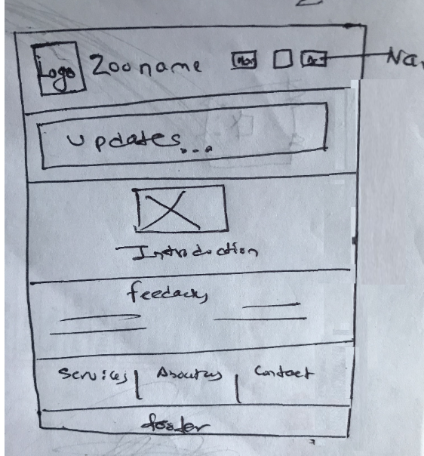

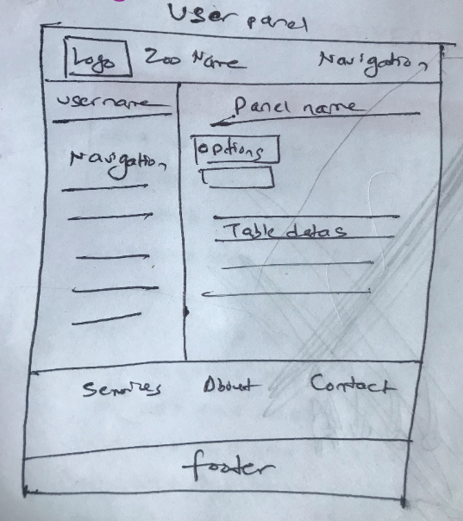

### 2.1.7 Workshop Observation Critical Review

There was 2 group participating in the workshop both 1 and 2 where from Group B , team 1 was the initial group and we were the team 2 . During the workshop of team 1 , several observations were made so that we can critically evaluate their performance throughout the session and hence we can improve on us so that the whole workshop can be as effective as it is supposed to be.

With the given circumstances, the agenda and the processes followed during the session of workshop were both appropriate and suitable which lead for the successful in gathering knowledge that is essential for the problem domain.

Starting with pointing the positive part of the observation for workshop, it is listed below.

* A notable outline about the workshop's objectives ensured the clients awareness towards the session intention for and what are the expected requirement for the session.
* The provision of additional documentations for clients enabled them to have an insight understanding of the intention or purpose of the workshop that were to be discussed while also ensuring that they had required materials to browse when necessary.
* Providing attendee engagement rules which set the tone for the workshop and mitigated the political preconceptions.
* Make use of brainstorms for monitoring discussed ideas which provides a medium for building ideas by visualizing the topics and ideas that have already been discussed, freeing the minds of customers to consider other potentially connecting topics. This makes a sense of break through the normal routine of problem-thinking with the clear medium for input.
* Allowed stakeholders to express opposing views in a descriptive manner during a dispute over classification, tickets booking etc. before closing the dispute.

Beside the fact of some positive points from the observation to workshop there we few negative points pointed out which is listed below.

* Questions related to budgeting for the project which is inappropriate as it is bad practice for business environment where the workshop is designed for the gathering of information about problem domain.
* Over explanation of technical term to client for development methodology as the clients were new to online system which made the environment of workshop for client feel unqualified for discussing over same topic.
* Separation of client into different phase of timing in session causes the waste of time due to repetition of question as well as some question left behind to ask .
* Lack of willingness of attendee from the developer team due to interruption of clients during discussion of relevant topic in consider to aims and objectives.
* Lack of basic knowledge developed during the workshop that left potholes in the overall understanding of the session or system to develop.

With the positive points and negative points, for the improvement of workshop some of key point should be followed which are listed below:

* Restrict splitting participants during meeting as it will motivate other to give their insight view for the relevant topic .
* There will be many interactions with client on different topic where one of the topics can be financial so that is the place for budget discussion.
* Using of technical term while discussing with client is in appropriate as all the attendee are not be from the technical background.
* Encourage the internal exchange of ideas to further expand on the various points of view that the participants can have ensuring that all discussions are relevant.

### 2.1.8 Other Problem Domain research

This section for other problem domain research is focused on of comparable analysis of the existing online systems and the related legislation acts for development. These research elements are essential to the development for the better understanding of the problem domain relevant to the topic and provide much of the foundation for development .

#### 2.1.8.1 Comparable Software System Review

In other to be the system competitive in the market, certain research should be done regarding system either their exits some system like we are going to develop. For this section few of the online zoo system are compared with their individual specification and the process how they work. The zoo system that will be used for system review are : ZSL London Zoo, San Diego Zoo and Saint Louis Zoo.

**ZSL London Zoo**

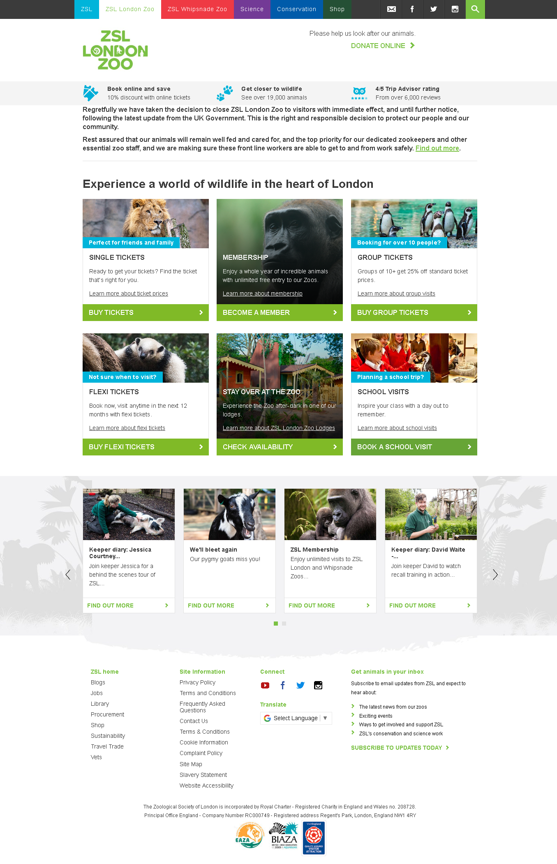Figure 1 : ZSL London Zoo

Source : (ZSL London Zoo, 2020)

The zoo design structure for system is good but complex when it came to search or filter animal on the basic of their name, type, or any habitat. Individually cannot able to create or signup account from outside of country . The payment method for sponsorship to animal is complex as all the details for billing need to be done every time. There is not any entertaining panel for kids so that they can enroll like kiosk

**San Diego Zoo**

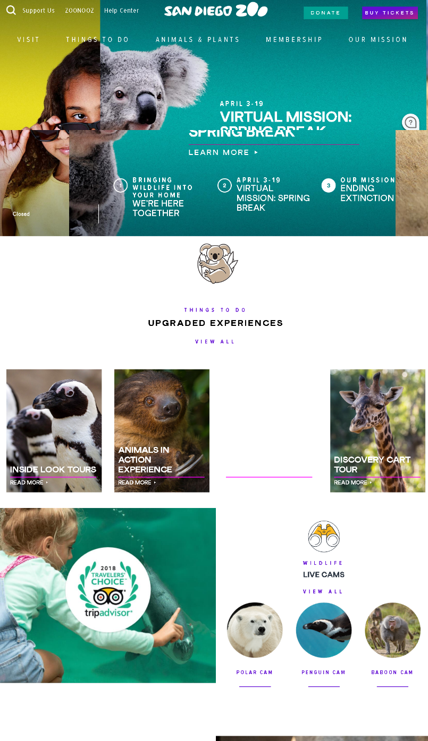

Figure 2 : San Diego Zoo

Source : (San Diego Zoo® Official Site | Voted #1 Zoo in the World, 2020)

The design structure for this zoo is more beautiful then ZSL zoo but filtering animal for searching is available but not with different specification which makes it less reliable when it comes to search animal on the basic of characteristics. The payment process for tickets is slower . To create account, you need to have a membership which is not preferable for everyone, so you have to login as guest for tickets purchasing.

**Saint Louis Zoo**

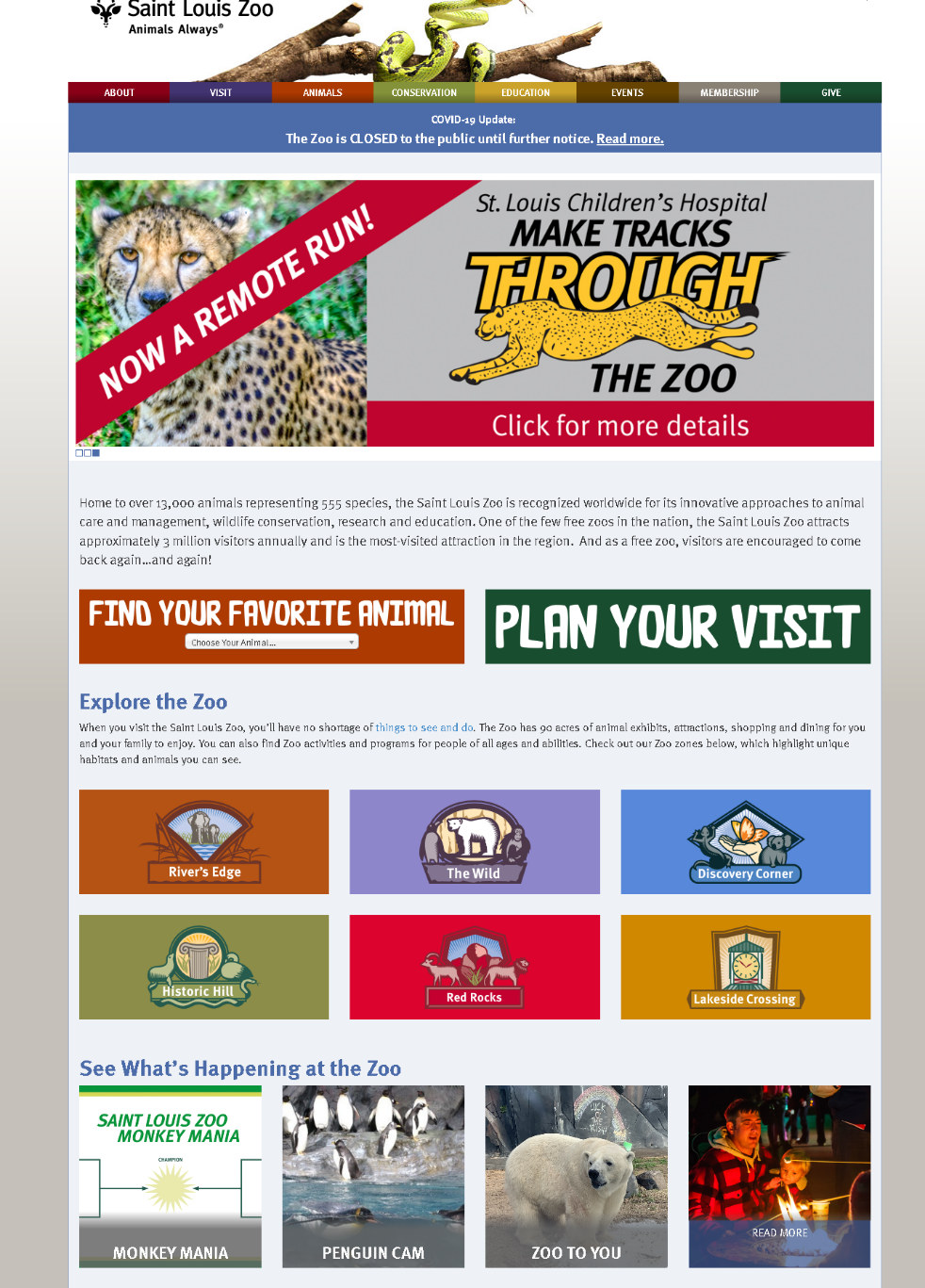

Figure 3 : Saint Louis Zoo

Source : (Home | Saint Louis Zoo, 2020)

Design for this zoo structure is good but there is not any search option for animals so that users can filter according to their choices. There is not online payment system and individual cannot create account . It is look like system is for the purpose of knowing about zoo.

**Overall Comparable system review table**

Table 10 : Comparable System

|  |  |  |  |
| --- | --- | --- | --- |
| **Event / Actions / Description** | **ZSL London Zoo** | **San Diego Zoo** | **Saint Louis Zoo** |
| System Layout, design | Good | Attractive | Good |
| Creating account | Only people of London can | Only as a Guest | Not available |
| Online ticketing | Good | Slow | Not available |
| Sponsoring animal online | Many data to enter but good | Slow | Not available |
| Filtering animals with name | No | Yes | No |
| Different criteria for filtering | No | No | No |
| View All animals’ photos | No | No | No |
| Calendar | Yes | Yes | No |
| Events Update | Yes | Yes | Yes |
| Kiosk or educational entertainment for kids | No | No | No |
| Footer design for system | Nearly same content and design | | |

#### 2.1.8.2 Development Relevant Legislation

Initially before implementing any system, there should be any rules and regulations that needs to be followed throughout the system and after the implementation of system too. For online system there are few legislations acts that needs to be considered to make the users comfortable with their information and no one get harmed with the system as well as no one get discriminated by the cause of system. Below are few legislations acts that will be in action for this system.

* **Computer Misuse Act** 1990 (Legislation.gov.uk, 2019)

Offences that should be considered when developing online system or software according to legislation of UK government are given below:

* 1. Unauthorised access to computer material.
  2. Unauthorised access with intent to commit or facilitate commission of further offences.
  3. Unauthorised acts with intent to impair, or with recklessness as to impairing, operation of computer, etc.

3ZA.Unauthorised acts causing, or creating risk of, serious damage

3A.Making, supplying or obtaining articles for use in offence under section 1, 3 or 3ZA

* **Copyright, Designs and Patents Act 1988** (Service, 2019)

The Copyright, Designs and Patents Act 1988, is the current UK copyright law. It gives the creators of literary, dramatic, musical and artistic works the right to control the ways in which their material may be used. The rights cover: Broadcast and public performance, copying, adapting, issuing, renting and lending copies to the public. In many cases, the creator will also have the right to be identified as the author and to object to distortions of his work.

Copyright occurs when a work is created by a person or entity and refers to

a work if it is considered original, and shows a degree of labor, talent or judgment.

* **Data Protection Act 2018** (GOV.UK, 2019)

The Data Protection Act 2018 regulates how businesses, or the government use your personal information. Those responsible for using personal data must obey specific guidelines called 'principles of data security. They will see to it that the knowledge is:

* used fairly, lawfully and transparently
* used for specified, explicit purposes
* used in a way that is adequate, relevant and limited to only what is necessary
* accurate and, where necessary, kept up to date
* kept for no longer than is necessary
* handled in a way that ensures appropriate security, including protection against unlawful or unauthorised processing, access, loss, destruction or damage

There is stronger legal protection for more sensitive information, such as:

* race
* ethnic background
* political opinions
* religious beliefs
* trade union membership
* genetics
* biometrics (where used for identification)
* health
* sex life or orientation
* **The Equality Act 2010** (Key Principles of Equality Law - The University of Nottingham, 2020)

The Equality Act 2010 extends protection based on association and perception already applicable to race, sexual orientation and religion or belief to include age, disability, gender reassignment, sex and pregnancy and maternity.

* Associative Discrimination – whereby a person is treated less favourably because of his/her association with someone who has a protected characteristic.  For example, a employee is overlooked for promotion because their partner has undergone gender reassignment
* Perceptive discrimination – whereby a person is treated less favourably because he/she is mistakenly believed to have one of the protected characteristics.  For example, an employer decides not to promote a female employee because senior staff believe her to pregnant irrespective of whether she is pregnant or not.

## 2.2 Requirements Specification

Requirement specification for this section of report specifies the requirements that the solution method must fulfill to solve the problems which were previously described, using the information collected during the workshops followed for elicitation activities. Requirement specifications consist of, description of problem domain, , performance requirements , functional specifications, design constraints as well as commercial constraints.

### 2.2.1 Problem Domain Description

The definition of the problem domain defines the world where the problem resides, excluding external variables that have no effect on problem domain, effectively identify the problems and its entities with attributes. For this prototype development, the key entities are existing business operations and its limitations ,comparable existing systems, legislations act as well as key stakeholders.

Below is the table for problem domain description and elicitation strategies followed for getting information to develop the solution system can be seen.

Table 11 : Problem domain entities and elicitation strategies

|  |  |
| --- | --- |
| **Problem Domain Entities** | **Elicitation Strategies** |
| **Stakeholders**   * Mark Jones (Manager) * John Smith (Visitor) * Georgia Rodgers(Senior Administrator) * Laura Brown (Sponsor) | * 1st Workshop on problem domain for the understanding of current problems, ideal features, inspiration short omissions, etc. * 2nd Workshop on problem solving and starting specification stage covering problem for feature solutions and their implementation priority with the analysis of possible designs. |
| **Comparable System** | * Background reading of existing online zoo system to know their pros and cons so that it will be easier to design the system accordingly. |
| **Existing Business Operations** | * Clear understanding of all the documents provided by the client as well as information provided during meetings about their current limitations, operations, polices and the type of data stored overall the workflow in the clerical based system. |
| **Legislation Acts** | * Research on legislations act by UK government which should be strictly followed while developing online systems like data protection act, equality act, Copyright and Patient act. |

#### 2.2.1.1 Existing Business Operation

As the Clay brook zoo was already running as clerical based, there are many operations followed as working procedure for the zoo but due to some problem domain they want to move to new online based system where all the information needs to be stored and all the work process should done now forward.

Identifying existing business processes within the framework of the problem domain without residing can helps the solution system to map working process and data flows for addressing , while also help to generalize the existing data values or simply attributes. The following lists defines the present business operations.

* Users Registration
* Currently there is no specific registration for individual except for visiting purpose.
* Manger deals with the visitors coming.
* Visitors pay for tickets in person at the ticket counter.
* Animal Operations
* Animal watchlist and case history is managed by Manger.
* Sponsoring animal
* Senior administrator Georgia deals with all the sponsorship scheme for animals.
* Watchlist
* Zookeeper will be responsible for watchlist.

#### 2.2.1.2 Summary of Existing Business Limitations

Existing system with limitations is the prior key points that lead to the introduction of a new solution system and hence clearly define the limitation faced in the existing framework that the new software framework solution needs to solved in order to justify the issue in its domain effectively. The present weakness of company can be summaries with the following points below.

1. The current system is not capable of reaching to all the people out there due to its less accessibility and online presence .
2. The que for ticket purchasing is long and all the visitors must wait for their turn.
3. People reach out to zoo office by calling to know about their services and the animals kept.
4. Sponsors having difficult to visit every time whenever they want to sponsor new animal.
5. Visitors are not able to see every animal while visiting due to animal sleeping or staying inside their cage so that a gallery of animals can help.
6. Admin must individually response to all the sponsor that what kind of animal they are sponsoring.
7. Some rare and critical animal are not getting sponsorship due to unavailability of their details for sponsors.
8. Sometime due to some unexpected event zoo closes where visitors cannot know he update of zoo.
9. Admin must personally remove the animal details from the register for some cases like transferred or dead.
10. Admin. Manager are not able to response to query they get through calls.
11. Difficult to enter each animal details manually.
12. All the competitor is using computerized system which makes them lead ahead of us.
13. Signage of sponsors are kept behind the animals and hence it makes sponsor query about the signage which is not noticeable and not updated over year.
14. Unable to make children interest due to new tech.

### 2.2.2 Functional Requirements

In this section, the prototype system's functional requirement will be detailed out defining the necessary functionality to effectively solve the specified problems. Within the brief and during the elicitation activities, the following software features and operations were defined to adequately generate a prototype system that justifies the problem(s) previously mentioned.

In the individual table below, each function and its operations are listed with the access level defined for user type either visitor , admin , manager, or zookeeper . Visitor can either buy tickets or as well can sponsor animal too without creating any other account. For each of the specified operation domains like entities, the data attributes are also described inside tables with textual explanations of what concerns each data attribute.

Table 12 : Users record operations and access Levels

|  |  |  |  |  |  |
| --- | --- | --- | --- | --- | --- |
| **Operation** | **Admin** | **Manger** | **Zookeeper** | **Visitor** | **Temp Staff** |
| Create | Full access | Restricted to self | Restricted to self | Restricted to self | No access |
| Update | Full access | Restricted to self | Restricted to self | Restricted to self | No access |
| Delete | Full access | No access | No access | Restricted to self | No access |
| Search | Full access | Full Access | Restricted to self | Restricted to self | No access |
| Read | Full access | Full Access | Restricted to self | Restricted to self | No access |

Table 13 : Users record attributes

|  |  |  |  |  |
| --- | --- | --- | --- | --- |
| Attributes | DATATYPES | KEYS | DEFAULTS/  CONSTRAINTS | Description with Examples |
| Id | NUMBER | pk | UNIQUE , Auto increment | Unique Identifier for user starting from 1  Normally used inside the system without visibility |
| username | CHARFIELD |  | UNIQUE | Unique identifier for user to be known and used while querying data and adding during model objects |
| first_name | CHARFIELD(30) |  | NOT NULL | Used to know the user first name as personal details |
| last_name | CHARFIELD(30) |  | NOT NULL | Used to know the user last name as personal details |
| mail | EMAILFIELD |  | UNIQUE | Unique Identifier for user s and used during payment as personal and contact details |
| password | SYSTEM DEFAULT |  | NOT NULL | Used by users to login to their account with personal information about their events in zoo |
| role | CHARFIELD(15) |  | DEFAULT = ‘Visitor’ | It determines the role of the user for access level |

Table 14 : Animal record operations and access levels

|  |  |  |  |  |  |
| --- | --- | --- | --- | --- | --- |
| **Operation** | **Admin** | **Manger** | **Zookeeper** | **Visitor** | **Temp Staff** |
| Create | Full Access | Full Access | No access | No access | No access |
| Update | Full Access | Full Access | No access | No access | No access |
| Delete | Full Access | Full Access | No access | No access | No access |
| Search | Full Access | Full Access | Full Access | Limited to visibility | No access |
| Read | Full Access | Full Access | Full Access | Limited to visibility | No access |

Table 15 : Animal record attributes and description

|  |  |  |  |  |
| --- | --- | --- | --- | --- |
| Attributes | DATATYPES | KEYS | DEFAULTS/  CONSTRAINTS | Description with examples |
| Id | NUMBER | pk | UNIQUE, AUTO INCREMENT | Unique identifier to animal which will be used throughout the system for any events related to animal to confirm and the id starts from 1 |
| classification | CHARFIELD(50) |  |  | Characteristic of animal with the sub specification about animal either mammal , bird etc. or their individual characteristics |
| species | CHARFIELD(50) |  | NOT NULL | Animal type for the identification |
| name | CHARFIELD(50) |  | NOT NULL | Name of individual animal which will be used to confirm animal with id |
| gender | CHARFIELD(10) |  | DEFAULT = ‘Female’ | Sex of animal to use during medical attention |
| dob | DATEFIELD() |  |  | Animal date of birth which will be guessed if not known for official purpose |
| date_joined | DATEFIELD() |  |  | Day of animal joined to see its status |
| condition | CHARFIELD(10) |  |  | Identification of animal condition which will be watch by zookeeper |
| location | CHARFIELD(50) |  | NOT NULL | Location of the animal in the zoo |
| born_place | CHARFIELD(50) |  |  | Animal born place either captivity or wild stored accordingly |
| population_distribution | CHARFIELD(6) |  |  | Distribution of population of animal to know if they are rare or not |
| average_dimension | TEXTFIELD() |  |  | It will give idea about the animal that how it looks after watching photos online |
| average_life_span | TEXTFIELD() |  |  | Detail of animal that how much can it live |
| dietary_requirement | TEXTFIELD() |  |  | Know the diet the animal use to survive so that it makes sponsors easy to pay accordingly |
| natural_habitat | TEXTFIELD() |  |  | It suggests the animal where it belongs and what its need |
| colour_variants | CHARFIELD(50) |  |  | To justify the animal and know |
| visibility | CHARFIELD(10) |  | DEFAULT = ‘Visible’ | Archive animal in case of transferred or dead |

Table 16 : Animal Classification Reptile

|  |  |  |  |
| --- | --- | --- | --- |
| Attributes | DATATYPES | KEYS | DEFAULTS/  CONSTRAINTS |
| Id | NUMBER | pk | UNIQUE, AUTO INCREMENT |
| animal | DEFAULT | fk(Animal) | NOT NULL |
| reproduction_type | CHARFIELD(10) |  | NOT NULL |
| offspring_number | INTEGERFIELD |  | NOT NULL |
| clutch_size | CHARFIELD(50) |  | NOT NULL |

Table 17 : Animal Classification Mammal

|  |  |  |  |
| --- | --- | --- | --- |
| Attributes | DATATYPES | KEYS | DEFAULTS/  CONSTRAINTS |
| Id | NUMBER | pk | UNIQUE, AUTO INCREMENT |
| animal | DEFAULT | fk(Animal) | NOT NULL |
| gestational_period | CHARFIELD(50) |  | NOT NULL |
| mammal_category | CHARFIELD(50) |  | NOT NULL |
| average_temperature | CHARFIELD(20) |  | NOT NULL |

Table 18 : Animal Classification Bird

|  |  |  |  |
| --- | --- | --- | --- |
| Attributes | DATATYPES | KEYS | DEFAULTS/  CONSTRAINTS |
| Id | NUMBER | pk | UNIQUE, AUTO INCREMENT |
| animal | DEFAULT | fk(Animal) | NOT NULL |
| nest_constrcution | CHARFIELD(100) |  | NOT NULL |
| clutch_Size | CHARFIELD(50) |  | NOT NULL |
| wing_span | CHARFIELD(50) |  | NOT NULL |
| fly_Ability | CHARFIELD(3) |  | NOT NULL |

Table 19 : Animal Classification Fish

|  |  |  |  |
| --- | --- | --- | --- |
| Attributes | DATATYPES | KEYS | DEFAULTS/  CONSTRAINTS |
| Id | NUMBER | pk | UNIQUE, AUTO INCREMENT |
| animal | DEFAULT | fk(Animal) | NOT NULL |
| average_temperature | CHARFIELD(20) |  | NOT NULL |
| water_type | CHARFIELD(50) |  | NOT NULL |

Table 20 : Watchlist operation access levels

|  |  |  |  |  |  |
| --- | --- | --- | --- | --- | --- |
| **Operation** | **Admin** | **Manger** | **Zookeeper** | **Visitor** | **Temp Staff** |
| Create | Full Access | Full Access | Full Access | No Access | Full Access |
| Update | Full Access | Full Access | Full Access | No Access | Full Access |
| Delete | Full Access | Full Access | Full Access | No Access | Full Access |
| Search | Full Access | Full Access | Full Access | No Access | Full Access |
| Read | Full Access | Full Access | Full Access | No Access | Full Access |

Table 21 : Watchlist attributes and it is description

|  |  |  |  |  |
| --- | --- | --- | --- | --- |
| Attributes | DATATYPES | KEYS | DEFAULTS/  CONSTRAINTS | Description with animals |
| Id | NUMBER | pk | UNIQUE, AUTO INCREMENT | Unique identifier to distinguish each watch list where same animal can be watched multiple times .  Id starts from 2 |
| animal | DEFAULT | fk(Animal) | NOT NULL | Key of the animal which will help to know which animal is watched |
| condition | CHARFIELD(10) |  | DEFAULT=’Normal’ | The condition of the animal which provide information regarding who need how much attention |
| location | CHARFIELD(100) |  | NOT NULL | The location of the animal or the watching area |
| observation_date | DATEFIELD() |  |  | Date of the observation day for track to be use in medical attention |

Table 22 : Sponsors operation and access levels

|  |  |  |  |  |  |
| --- | --- | --- | --- | --- | --- |
| **Operation** | **Admin** | **Manger** | **Zookeeper** | **Visitor** | **Temp Staff** |
| Create | Full access | No access | No access | Access if visitor is sponsor | No access |
| Update | Full access | No access | No access | Access if visitor is sponsor | No access |
| Delete | Full access | No access | No access | Access if visitor is sponsor | No access |
| Search | Full access | Full access | No access | Access if visitor is sponsor | No access |
| Read | Full access | Full access | Access restricted to signage | Access restricted to signage and Access if visitor is sponsor | No access |

Table 23 : Sponsorship attributes and its description

|  |  |  |  |  |
| --- | --- | --- | --- | --- |
| Attributes | DATATYPES | KEYS | DEFAULTS/  CONSTRAINTS | Description with examples |
| Id | NUMBER | pk | UNIQUE, AUTO INCREMENT | Unique identifier for sponsors to be distinguish which will be used to query and during input data  Id starts from 1 |
| name | CHARFIELD(100) |  | NOT NULL | Name of the company or person form sponsor data and query purpose |
| existing_customer | CHARFIELD(10) |  | DEFAULT = ‘No’ | To know about the sponsor either existing or new |
| official_id | CHARFIELD(70) |  | NOT NULL | Personal details of sponsor to ensure about the work |
| primary_contact | INTEGERFIELD() |  |  | Personal details of sponsor to ensure about the work |
| secondary_contact | INTEGERFIELD() |  |  | Personal details of sponsor to ensure about the work |
| address | CHARFIELD(100) |  | NOT NULL | Personal details of sponsor to ensure about the work |
| web_address | CHARFIELD(100) |  |  | Person or company website link so that visitor can go and check them |
| animal | DEFAULT | n:m(Animal) | NOT NULL | Animal holds the id and name so that it can be linked with sponsor to deal |
| sponsor_band | CHARFIELD(2) |  | DEFAULT = ‘A’ | Band of the sponsorship related to animal where It varies from A to E starting with 500 to 2500. |
| total_fee | INTEGERFIELD() |  |  | The total fee to sponsor the animal(s) according to band |
| agreement_period | CHARFIELD(100) |  | NOT NULL | Period for the sponsorship agreement which is generally from January first to 31 of December. |
| signage_area_percent | CHARFIELD(5) |  |  | It determines the signage are or the company portfolio to display |
| signage_photo | IMAGEFIELD() |  |  | Company of person logo |
| note | CHARFIELD(255) |  |  | Information or additional notes by customer / sponsor |
| sponsored_user | DEFAULT | n:m(User) |  | In case of person have account, which is used when person is personally sponsoring animal from website or telling admin to do so |
| payment_detail | CHARFIELD(50) |  |  | The details of payment from which source , it is complete by officials. |
| payment_received | CHARFIELD(3) |  | DEFAULT =’No’ | Confirmation of payment receiver, it is complete by officials. |
| review_date | DATEFIELD() |  |  | Confirmation date of sponsorship by admin |
| confirmed_staff | DEFAULT | fk(User) |  | Staff who confirmed the sponsorship and for now admin is only allowed. |

Table 24 : Updates operation and access levels

|  |  |  |  |  |  |
| --- | --- | --- | --- | --- | --- |
| **Operation** | **Admin** | **Manger** | **Zookeeper** | **Visitor** | **Temp Staff** |
| Create | Full Access | Full Access | No Access | No Access | No access |
| Update | Full Access | Full Access | No Access | No Access | No access |
| Delete | Full Access | Full Access | No Access | No Access | No access |
| Search | Full Access | Full Access | Full Access | No Access | No access |
| Read | Full Access | Full Access | Full Access | Full Access | No access |

Table 25 : Updates Attributes and description

|  |  |  |  |  |
| --- | --- | --- | --- | --- |
| Attributes | DATATYPES | KEYS | DEFAULTS/  CONSTRAINTS | Description with example |
| Id | NUMBER | pk | UNIQUE, AUTO INCREMENT | Unique identifier for updates which will be used internally and starts from 1 |
| heading | CHARFIELD(150) |  | NOT NULL | Heading describes the title of the updates to be displayed |
| description | TEXTFIELD() |  | NOT NULL | Description of the update for proper knowledge of understanding of visitors |
| date | DATEFIELD() |  | DEFAULT = ‘NOW’ | The date when update was published |
| uploaded_by | DEFAULT | fk(user) | NOT NULL | The user who upload the updates , in this system admin and manger have that privilege |

Table 26 : Operation for Message and access level

|  |  |  |  |  |  |
| --- | --- | --- | --- | --- | --- |
| Operation | Admin | Manger | Zookeeper | Visitor | **Temp Staff** |
| Create | Full access | Full access | No access | Full access | No access |
| Update | Full access | No access | No access | No access | No access |
| Delete | Full access | No access | No access | No access | No access |
| Search | Full access | Full access | No access | Full access | No access |
| Read | Full access | Full access | No access | Full access | No access |

Table 27 : Message attributes and description

|  |  |  |  |  |
| --- | --- | --- | --- | --- |
| Attributes | DATATYPES | KEYS | DEFAULTS/  CONSTRAINTS | Description with example |
| Id | NUMBER | pk | UNIQUE, AUTO INCREMENT | Unique identifier for message which will be used internally and starts from 1 |
| content | CHARFIELD(255) |  | NOT NULL | The message or information to be send for either visitor or officials |
| sender | DEFAULT | pk(user) | NOT NULL | The sender of the message which can be either visitor or the officials |
| receiver | DEFAULT | n:m(User) | NOT NULL | The receiver of the message which can be either visitor or the officials |
| date | DATEFIELD() |  | DEFAULT = ‘NOW’ | The date when message was sent to order the information |
| seen | BOOLEANFIELD |  | DEFAULT = ‘FALSE’ | Seen justifies either the message is read by user or not |

Table 28 : Booking operation and its access level

|  |  |  |  |  |  |
| --- | --- | --- | --- | --- | --- |
| **Operation** | **Admin** | **Manger** | **Zookeeper** | **Visitor** | **Temp Staff** |
| Create | Full access | Full access | No access | Restricted to self | Full access |
| Update | Full access | Full access | No access | Restricted to self | Full access |
| Delete | Full access | Full access | No access | Restricted to self | Full access |
| Search | Full access | Full access | No access | Restricted to self | Full access |
| Read | Full access | Full access | No access | Restricted to self | Full access |

Table 29 : Booking attributes and description

|  |  |  |  |  |
| --- | --- | --- | --- | --- |
| Attributes | DATATYPES | KEYS | DEFAULTS/  CONSTRAINTS | Description with example |
| Id | NUMBER | pk | UNIQUE, AUTO INCREMENT | Unique identifier for booking which will be used during internal query and payment process  It starts from 1 |
| name | CHARFIELD(30) |  |  | Name for the visitor, in case of non-user when people come personally to visit zoo |
| entry_date | DATEFIELD() |  | NOT NULL | The date for entry so that it can be known how many visitors will come |
| no_of_entries | INTEGERFIELD() |  |  | The number of entries for visit |
| booked_by | DEFAULT | fk(User) |  | In case of user from system to identify |
| total_cost | CHARFIELD(20) |  |  | The total cost will be auto generated which is set by zoo |
| payment | CHARFIELD(10) |  | DEFAULT = ‘No’ | Confirmation of payment , either given or not |
| date | DATEFIELD() |  | DEFAULT = ‘NOW | The date when the booking was made |

Table 30 : Feedback operation and access level

|  |  |  |  |  |  |
| --- | --- | --- | --- | --- | --- |
| **Operation** | **Admin** | **Manger** | **Zookeeper** | **Visitor** | **Temp Staff** |
| Create | No Access | No Access | No Access | Full Access | No Access |
| Update | No Access | No Access | No Access | No Access | No Access |
| Delete | Full Access | Full Access | No Access | Full Access | No Access |
| Search | Full Access | Full Access | No Access | Full Access | No Access |
| Read | Full Access | Full Access | Full Access | Full Access | No Access |

Table 31 : Feedback attributes and description

|  |  |  |  |  |
| --- | --- | --- | --- | --- |
| Attributes | DATATYPES | KEYS | DEFAULTS/  CONSTRAINTS | Description with example |
| Id | NUMBER | pk | UNIQUE, AUTO INCREMENT | Unique identifier for feedback which will be used internally and starts from 1 |
| description | TEXTFIELD () |  | NOT NULL | The feedback given by the visitor/sponsor |
| sender | DEFAULT | fk(User) | NOT NULL | The visitor/ sponsor |
| date | DATEFIELD () |  | DEFAULT = ‘NOW’ | The date when feedback is given |
| highlight | BOOLEANFIELD () |  | DEFAULT = FALSE | Highlighting the feedback will add it to the home page as words from visitors/ sponsors |

### 2.2.3 Proposed Prototype Development Blocks/Priority of Development

Replicating the sprints of agile methodology of development, this section breaks down the development of the solution system into blocks based on feature creation priorities which are development cycles that seek to deliver working applications within a time period . All the priority order for the development of features to be use in prototype was gathered during the elicitation activity from workshop 1 and 2 . Development block that have been constructed after finalizing with client is shown below.

* Development Block 1:
  + Modeling the section for model , views, and controller with preferred framework
  + Model creation or database creation
  + Styling of graphical user interface (GUI)
  + Connecting GUI with the database with controller which is views file for this system
  + Creating super user from Django framework to know the admin and use to carry other operation forward
  + Modelling of CRUD functionalities which are basically create, read, update, and delete
  + Addition of Animals and rendering in templates
* Development Block 2:
  + Access control by restricting users on the basic of role
  + Complex Classification for Animals
  + Controlling user section to move forward
  + Simple search criteria for users and animals
* Development Block 3:
  + Animal Catalogue
  + Addition complex characteristics for animal with different models
  + Joining sponsorship model with animal and user
  + Carryout out complex search operation related to attributes from models
* Development Block 4:
  + Implementation of extra functionalities
  + Message conversation between visitors and officials
  + Joining of watchlist with users
  + Updates Notification operation with CRUD
  + Online booking with CRUD
  + Online sponsorship for animals
  + Online payment
  + Feedback receiving and adding to home with highlighted feedback
  + ADHOC Report

Block 1 and 2 of Development seeks to create the core basic framework on which the following development blocks will construct and expand. It encompasses the minimum functionality defined in the original brief given by the stakeholder from zoo with the top priority orders features to be must. The basic framework on which the conceptual software system will be developed and the additional features of expanding the CMS (Content Management System) administrators to include the CRUD operations for each model in database is completed till development phase 2.

After , development phase 2 the additional complex system features / functionality described in the brief given by the client and other features found in the elicitation workshops will be included with each block development per week. The remaining model blocks are allocated the features according to priority in from the findings of elicitation workshop.

# 3 System Analysis & Design (Software Development Block 1)

The analysis and design for this system is the review of the information collected and stated in the report's Specifications section on software development block 1 and the first stage of formulating the proposed solution system. System analysis and implementation will follow preliminary design phases such as Unified Modeling Language diagram, flowcharts and ERD for database design.

## 3.1 Preliminary Design Stage

The information’s that were gathered during the requirement engineering with the designing methodology, which was followed, preliminary design stage looks after those. That information is also known as textual analysis to define entities to be included within the prototype. Textual research extracts nouns as well as noun-phrases as possible

subjects of candidates, and verbs that indicate accountability. As potential classes for software development block 1 have been identified the following nouns / noun-phrases & verbs listed below.

1. Users (READ)
2. Animals ( CRUD, Query)

After the development block 1 the complex and additional features that will be developed from development block 2 to 4, below are the identified nouns/ noun-phrases & verbs .

1. Users (CRUD, Query)
2. Classification (CRUD, Query)
3. Sponsorship (CRUD, Query)
4. Message(CREATE, READ, DELETE)
5. Updates (CRUD)
6. Feedback (CREATE,READ,DELETE)
7. Watchlist(CRUD, Query)
8. Booking(CRUD, Query)

## 3.2 UML Class Diagram

A UML diagram is a static structured diagram illustrating the design of structures using relationships and groups, their attributes, and their operations . The classes and operations that will be used to construct UML class diagram is same from the preliminary design stage. Below is the UML class diagram for this system prepared accordingly with the identified nouns/ noun-phrases from preliminary design stages.

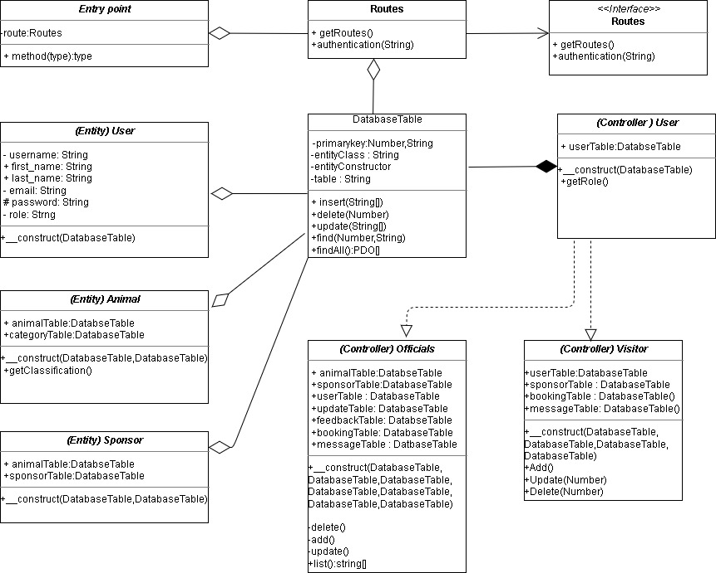

Figure 4 : UML class diagram

## 3.4 Entity Relationship Diagram

ERD represents the design of the attributes which were collected to success the development . Each entity will be linked with another for making relation so that it can ease the development. Below is the ERD for Clay brook zoo.

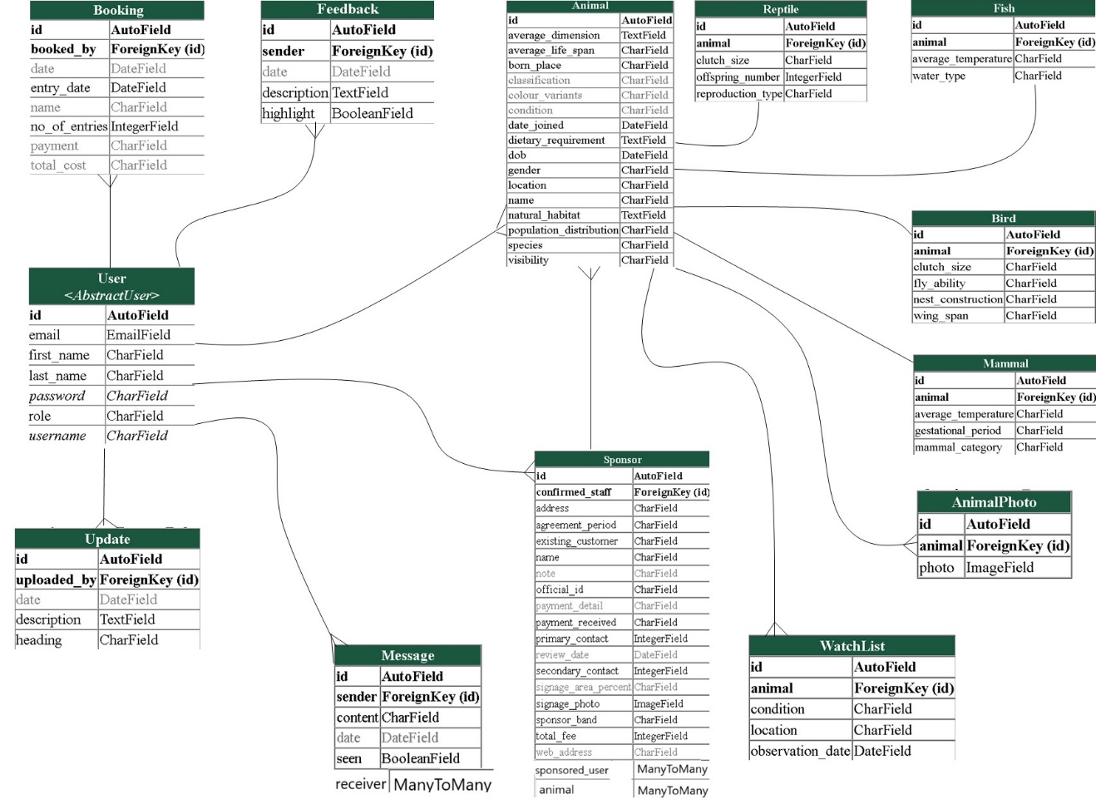

Figure 5 : Entity Relationship Diagram

## 3.5 System Use Case Diagram

In this system diagram, representation of user’s interaction showing the relation with different use cases in simplest form is shown. Below are the use cases for (visitor and admin), (manager, zookeeper, and temp staff)

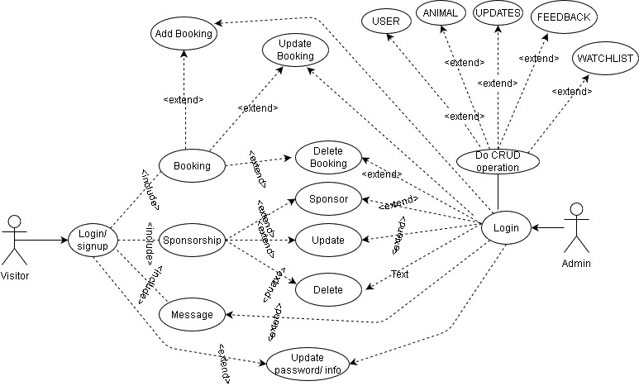

Figure 6 : Use case for visitor and admin

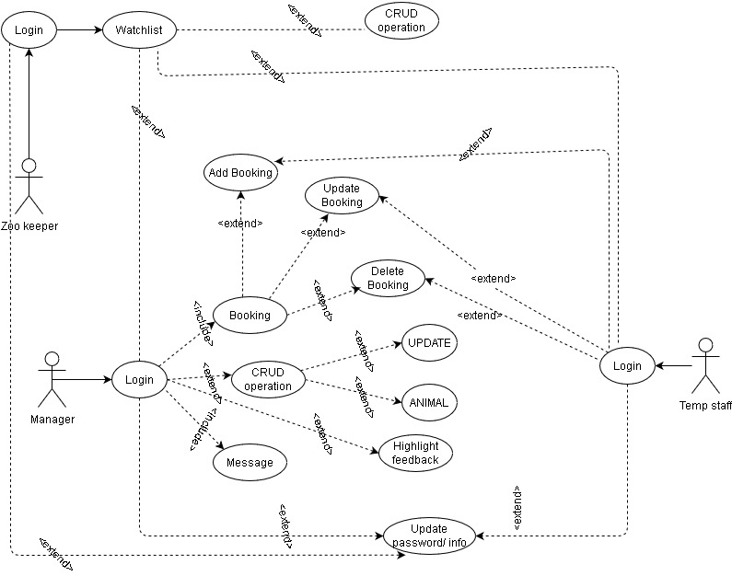

Figure 7 : Manager, Zookeeper, temp staff use case

## 3.5 System Workflow Flowcharts

To accurate the system workflow it must be based on rules and with the help of flowchart we can decide either the system work with the given situation in what manner. Below are the flowcharts for the system to decide the system workflow.

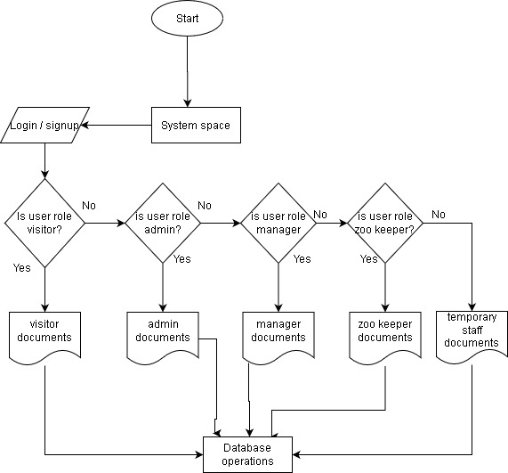

Figure 8 : System flow chart

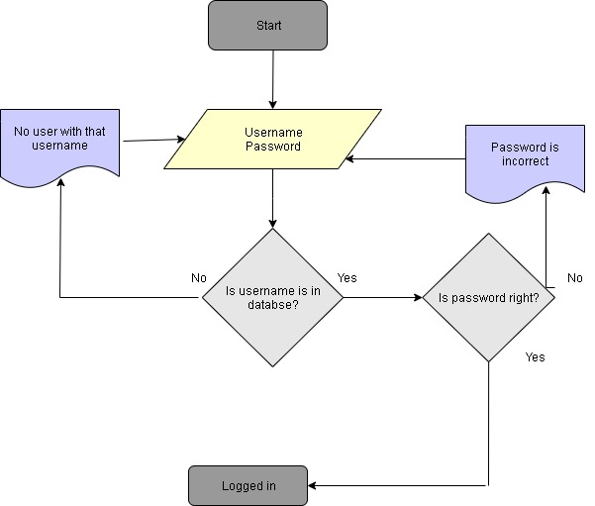

Figure 9 : login process flowchart

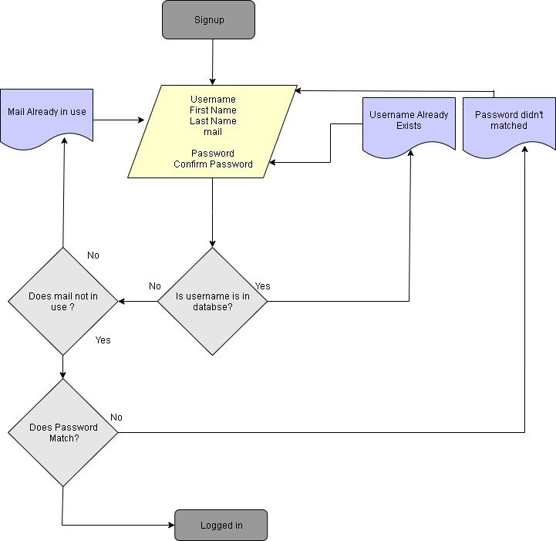

Figure 10 : Signup process flowchart

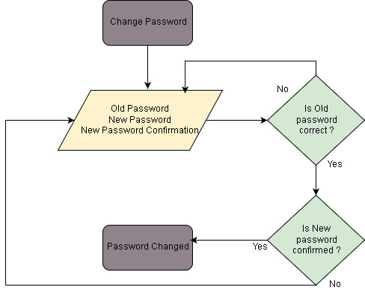

Figure 11 : Password change flowchart

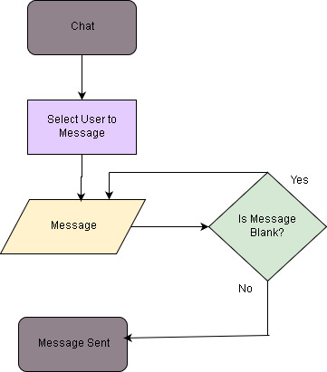

Figure 12 : Admin panel message process

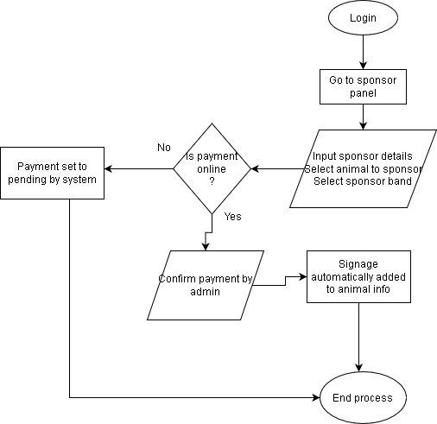

Figure 13 : Sponsorship process flowchart

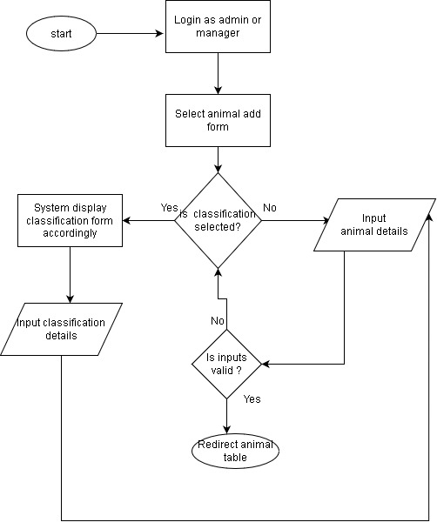

Figure 14 : Animal addition process flowchart

## 3.6 System Navigation Flowcharts

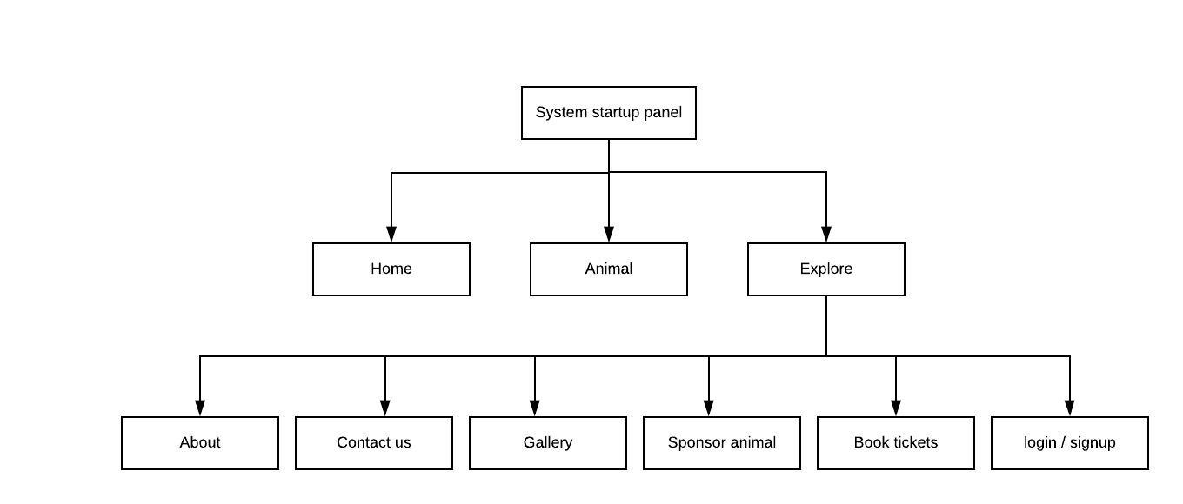

Figure 15 : System main navigation flowchart

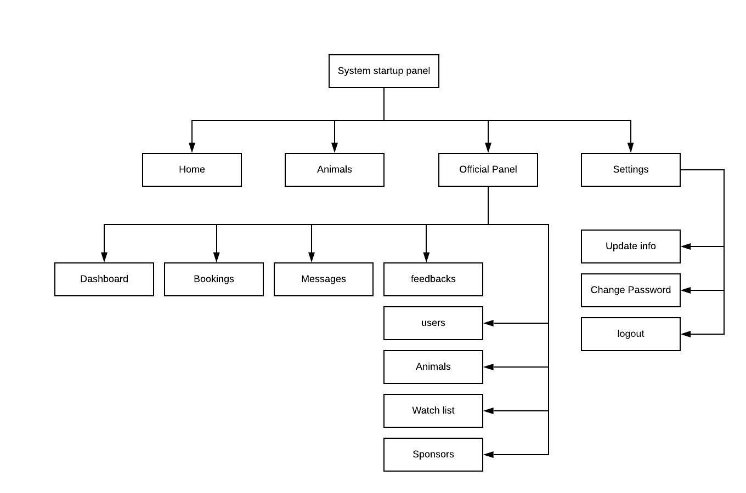Figure 16 : Admin and Manager Navigation flowchart

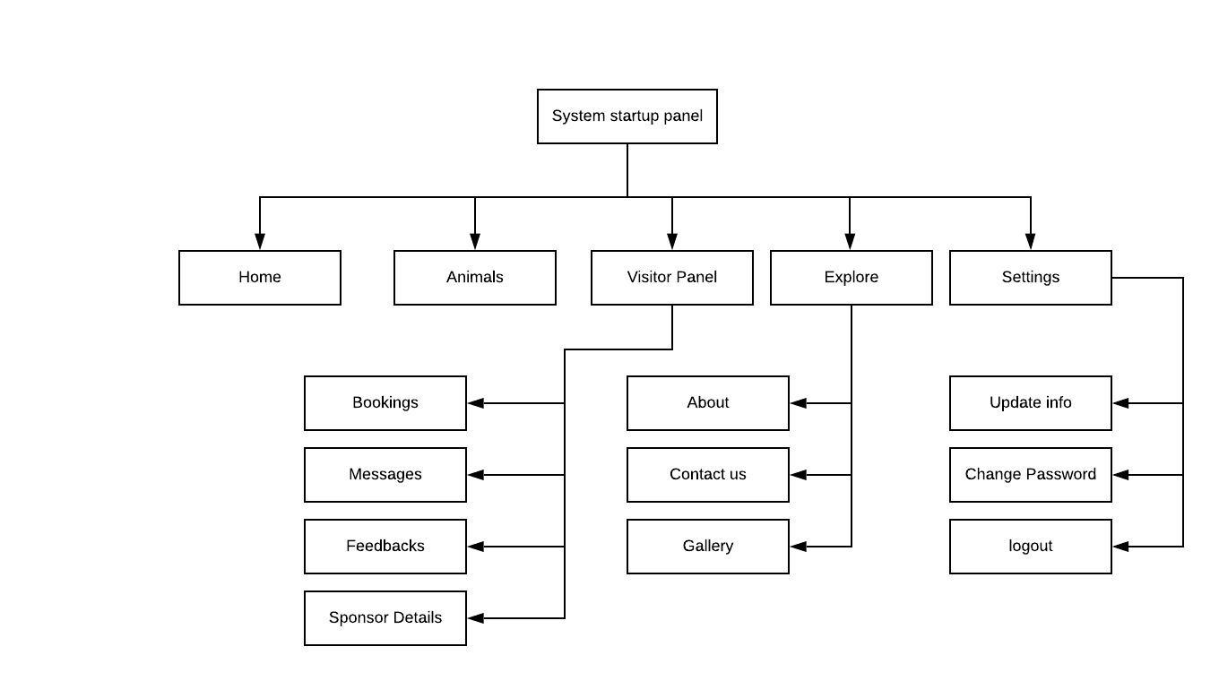Figure 17 : Visitor Navigation flowchart

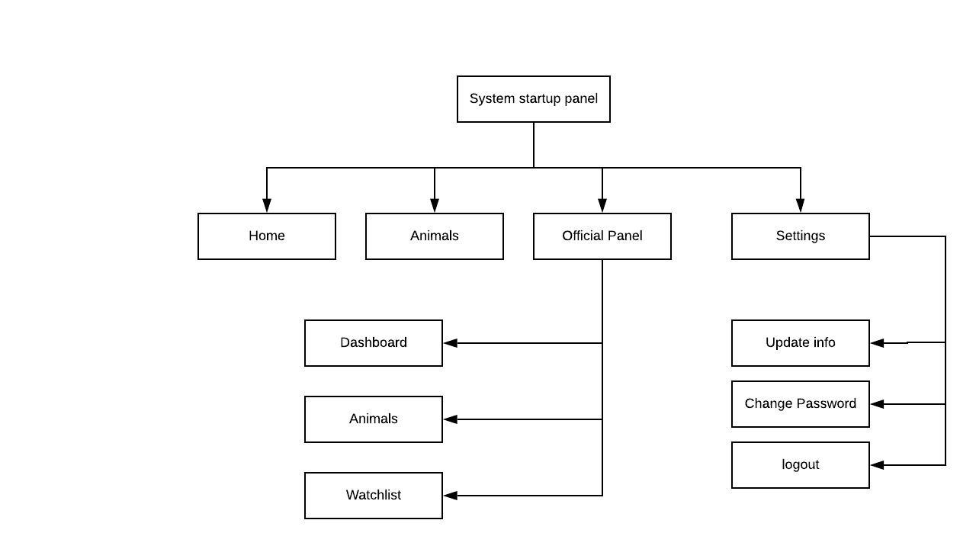

Fig : Zookeeper Navigation Flowchart

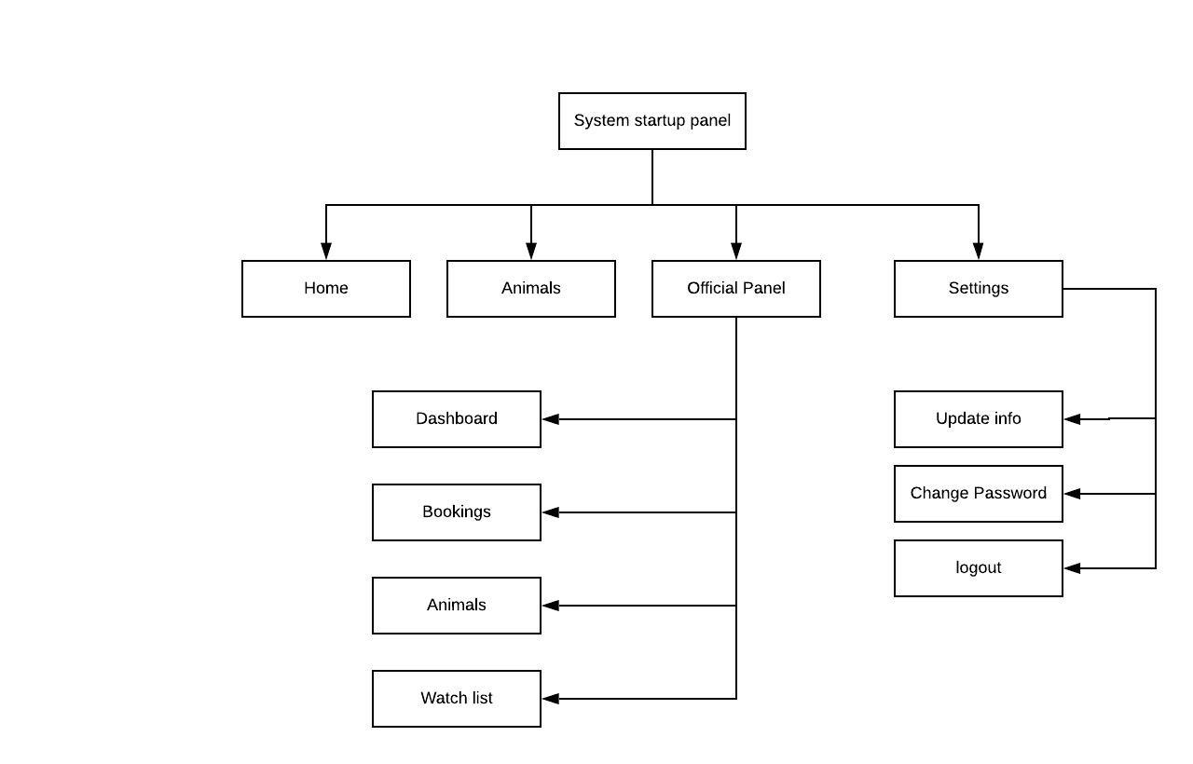

Figure 18 : Temporary staff Navigation Flowchart

# 4 System Build and Technical Notes (Software Development Block 1)

In this section, the program structures and technical which are the overview of the internal operating post building systems will be explained and noted out in order to give the reader idea about how the system works and how it is developed so that it can be further be useful when the system needs to updated by any other person. It attempts to clarify code which, in comparison to standard code, can appear considerably complex at surface level.

Programming languages , framework and packages used for this system build are:

* Python with Django framework
* Django rest framework
* Bootstrap
* HTML, CSS
* PayPal
* Social Django
* JS , J Query

Starting with the use of Django framework with python, first the system needs to be created in a virtual environment. With the installation of Django , project can be created with the command of “Django-admin startproject projectname” and then app can be created with “python manage.py startapp appname” where the developer needs to be in the root directory.

After the creation of the app the install apps or packages which will be in use for system should be registered in the settings.py file which is shown below.

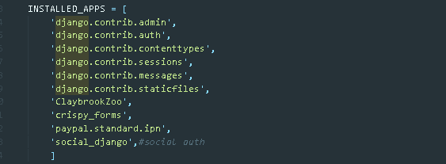

In the above installed apps, Clay brook zoo is the app name and on top of that they are default installed and registered packages which are of Django default admin. The package crispy forms are for bootstrap rendering, paypal.standard.ipn is for online payment whereas social Django is for existing media authentication for signup.

To give location for static files so that it will be easier when using MVC framework for Django. Below that redirect link for system is given according to condition like login and logout. Media URL and root are for the location of database uploaded file which will be stored there.

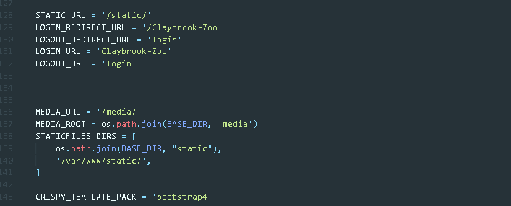

The MVC pattern for the system with Django is basically the separation of classes , functions, or operation accordingly. Below is the directory and files location sample take from this system where models.py contains the database classes for entities and attributes creation and the templates folder will contain html files for rendering where views acts as connecting models and template for which urls.py file contains links or redirect URL for the system to be send to views.

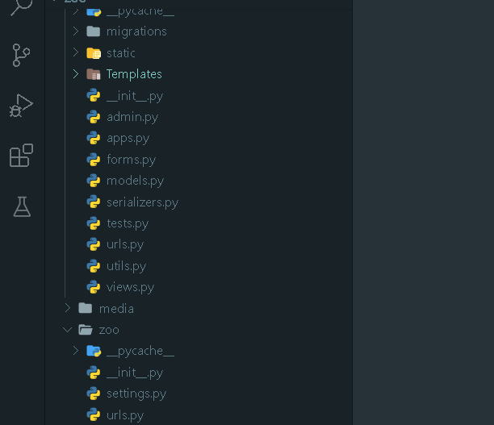

Below is the urls.py file content which gives the path to the URL and connect it to the views and render it. In the image the <str:action> will be used to get value from GET method and use in views.

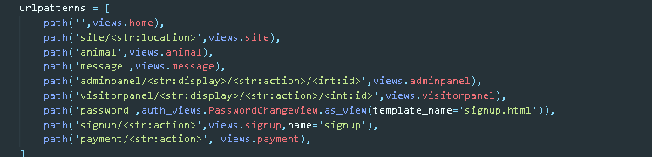

Below is the models.py file which is for database purpose and the class User will created table User in database and for this case we are extracting the abstract user which is already available when we have created with admin package. Some attributes will be added if necessary inside the class and for select option list is used assigning values to variable and then the name of the list will be added to attributes field with the choices option which can be set default with default option. The __str__ function return the class identifier which will be used throughout the system in case of knowing the object where it is primary key.

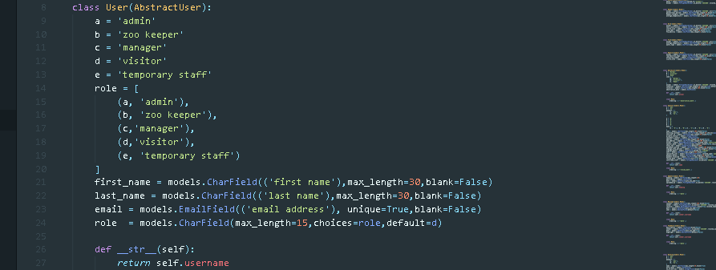

With every model creation the database needs to be migrated with the command python manage.py make migrations and then migrating with python manage.py migrate until then no effect will be done.

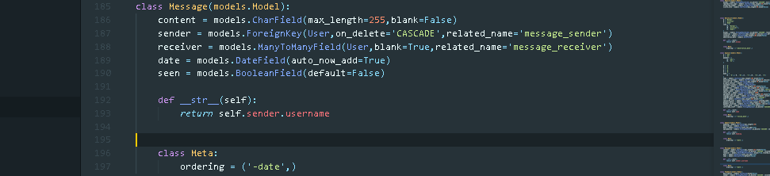

Above is the model Message in which foreign key and n:m is implemented. The foreign key suggest the related object in another table identified by pk and the n:m is same but in this case receiver can be many so that ManyToManyField is used and all the users are kept in that field which can is set add accordingly . For default ordering of model data with the creation of Meta class it can be ordered .

After models and URLs to query data and render to templates in views functions are used and below is the home function which render index file with the objects of update and feedback which is queried from models . The same process is followed for all the functions that is called from URLs.

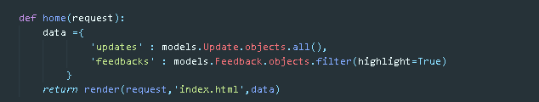

In the forms.py forms will be auto created with the given model so that there will be no need of writing forms in template. Below is on the form class for visitor sponsorship where at first inside meta class Sponsor model is connected and accordingly as of need the attributes are written. And in the widgets part we can manage forms attributes where for this case randomly is true so that in template total fee will not be edited by user.

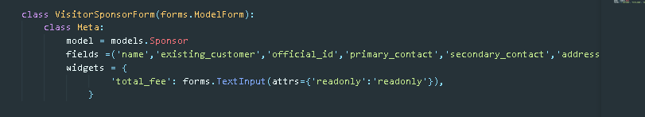

Nearly all the forms are created on the basic of above form class .

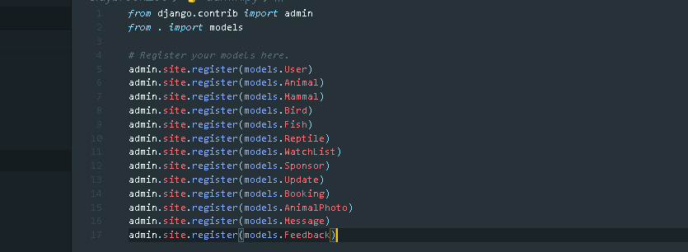

Whenever, we add model in database it need to be registered and above are all the models present in the system so that it will be showed in admin page for data managed and by default it is accessed by superuser.

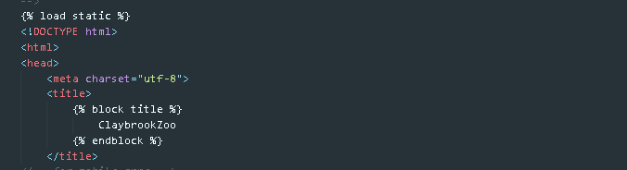

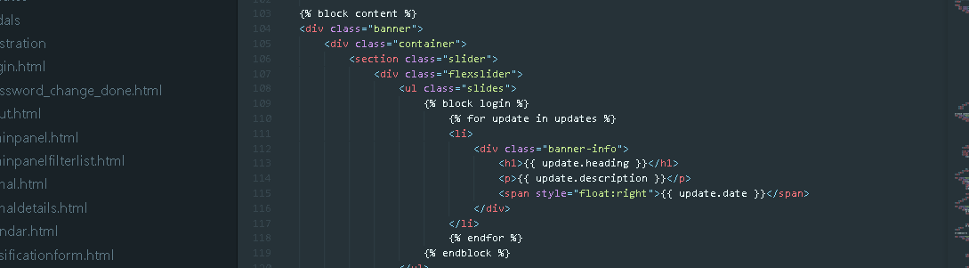

Above are the index file which is the root file for template where the header and footer of the system will be same, and the content part will be changed accordingly. The load static command will load static files like CSS, JS, system images in template and block command will replaces the content of the block with other content when requested by another html file . below is the html file which is rendering the content part of index to itself.

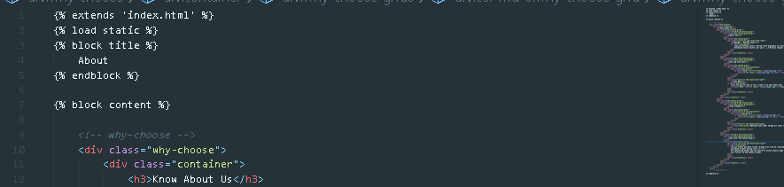

Now with all the information that is related as basic for the system development on which the addition of functions and classes will develop the system bigger we can move to the real functional part with JS files and views files which combines the user interface that we see.

Below is the ajax request which is used to render data when user searches or input data on the field on the event of onClick and onkeyUp. The process of getting data with GET request and the filtering the data from the model with the data that we get from GET method is same for every case. The same process is used for couple of function like filtering animals, bookings, users , sponsors etc. The icontains in the filter below is like “like” operator which match the data.

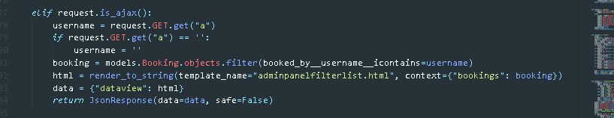

The data which is get through GET is method is send with ajax request which is on keyUp function in html which is shown below.

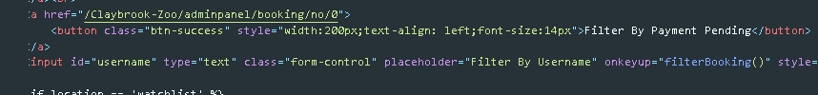

The username or alphabet entered in input is retrieved from JS which is show below with filterBooking() function where the URL constraint is the URL to the destination function in views and the delay_by_in_ms is the data that is going to render after filtering in views to the destination file. With ajax call the div with table data is will be rendered by passing the filtered data and on completed of response the dive will fadeout which be set to 1 for full fadeout vision. The req_param is the place where the GET method data is to be kept . The variable a is then passed to the URL in views function which is already discussed. The thing to remember is that the objects name should be same otherwise it won’t be render.

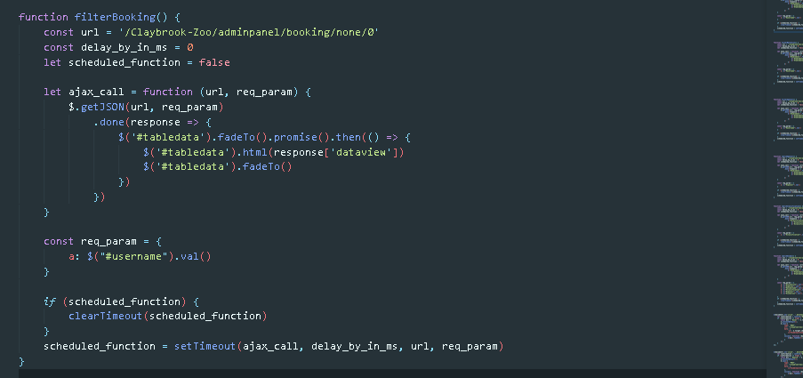

Below is the html file where the final filtered object will be rendered which is bookings and then with the help of loop it can be retrieved each data inside the object.

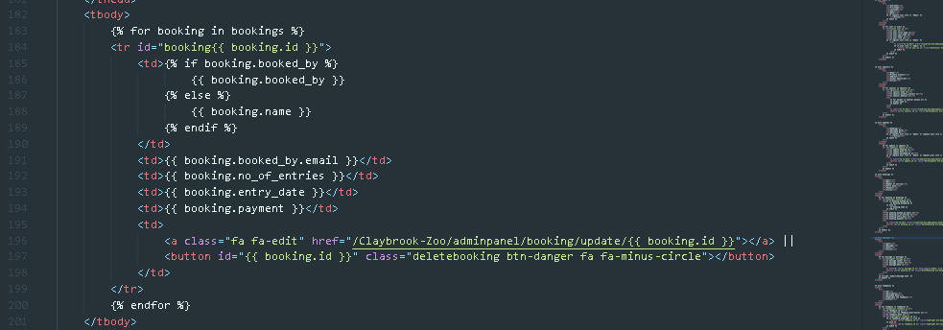

The ajax search technique for all the functions are same beside variables and models , just like this the operation for edit, delete, and add is also same with JS but the method used to send data will be POST.

Below is the step done for the success of operation.

First knowing the tag where the id for the model data is set and on which the operation should act. This is the case for archive which is all like delete and add but here the operation is for update. The class name “archieveanimal” plays a role on click of which JS function is triggered.

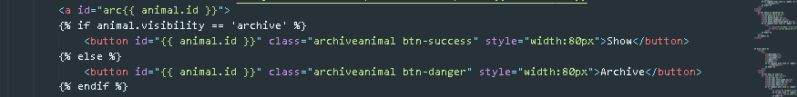

Below is the function for on click of archieveanimal in JS to use ajax .

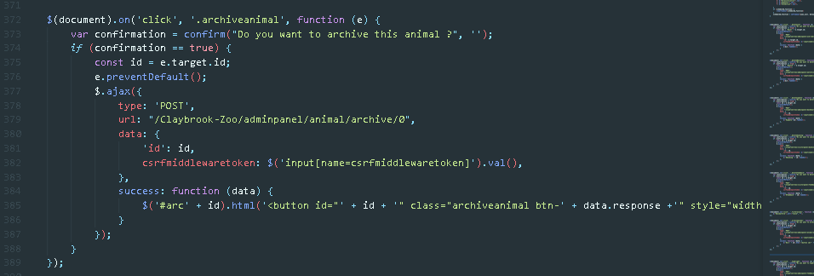

In the above code section at first the confirmation alert is pop out on which if users click yes then id is set with the target class id which is of archive animal ad then the page is set for prevent Default so that it will not reload but the action will be taken. After that , ajax is called where the type of data sending method is set which is POST and the URL is given and the data is provided in the data json format with csrf middlewaretoken which is must needed for any kind of access to database for change. The request send from here will strike to views function which then throw success message upon which the div with id archive is changed with the provided value.

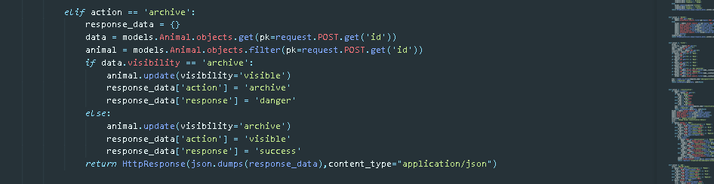

Above is the action taken after requesting with ajax where the send data is collected with request.POSt.get() method and then use according to filter. In the above expression the animal data is filter with the post data and then visibility is checked with comparison and then updated with update command which is only possible if we filter with filter command not with get command. After the success, the response to ajax is send through json formation which is for now is response_data passed with json dumps.

For the classification form which was complex for this system is also implemented with the search technique described above upon which if user selects the category then the form with the category name is rendered. Below is the expression for that action in views.

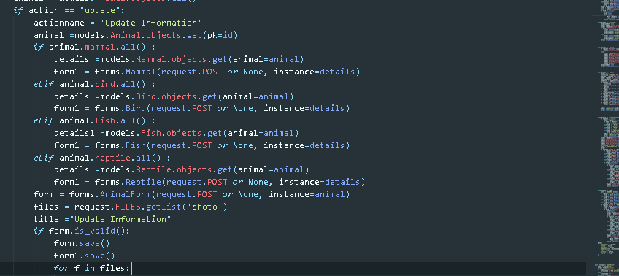

For each 4 form the data collected from ajax is compared and then form is set upon which the data entered will be save.

To implement payment functionality, the same technique is used for both booking and sponsorship where, at first taking with the example of sponsorship payment which is shown below, while saving data in sponsorship model it redirect to payment function where session is given the sponsor id upon which all the data from sponsor model will be retrieve where the amount and the name of the payment process is given in the PayPal. If the model is not found then it will show the 404 error and if found it checks for host and then data is send to PayPal which in the json format is collected in the form of PayPal with the initial filled value upon which the payment process is done. Inside the form the data of the payment is set as well the action after the redirecting to PayPal URL the cancelation and completion is set where notify URL, return URL and cancelled URL will act upon and complete our operation.

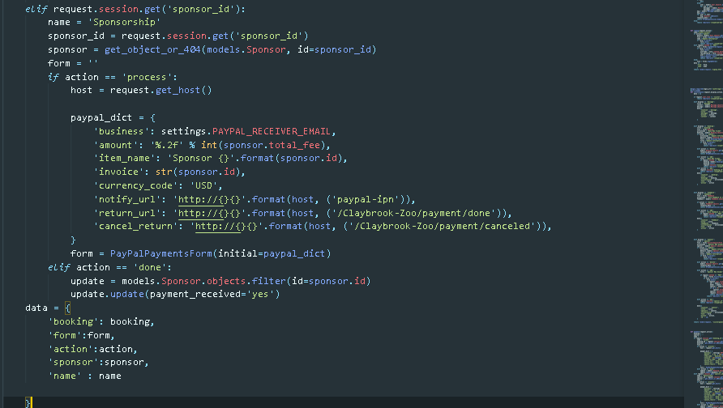

# 5 System Testing & Evaluation Strategy (Software Development Block 1)

After the completion of system implementation, it needs to be verified either the system can be practically used for real time without some bugs in it . For the success of system after implementation it need to be tested for its internal small units as well as external functional testing and evaluation so that it will be practically useful. Below are the testing and evaluation strategies used for this system.

## 5.1 Unit Testing

Unit testing is a software testing process of computer programming by which individual source code units, sets of one or more computer program modules, along with related control data, implementation procedures, and operating procedures, are tested to determine if they are appropriate for use. This unit testing is done after the completion of system.

At first with the help of coverage package, it need to be determined which small units are to be tested which can be seen after installation and adding to installed app in setting, coverage html command is to be run which shows the results of coverage as below.

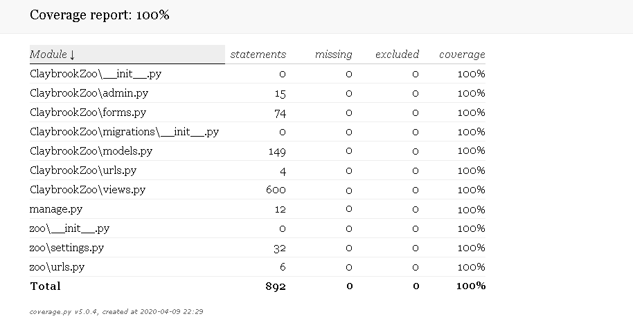

After the coverage report, starting with testing forms, models, and views in used in the system as a small unit with every valid and invalid data. Below is the test for forms after creating test cases in the tests folder with file like __init__.py, forms.py, models.py.

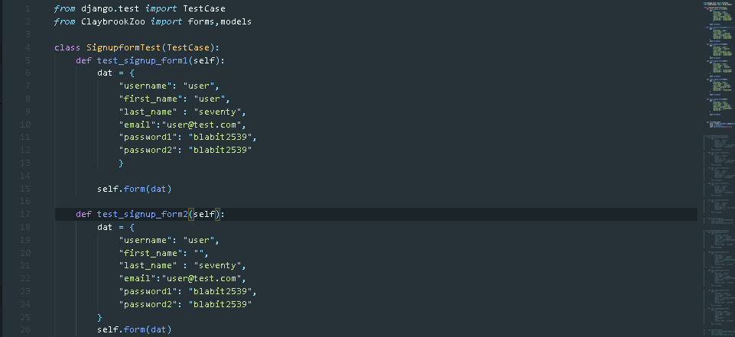Below is the SignupformTest class with different test cases which is then test in the form function called after data given and calling with self.form(data).

The form function is simply calling the forms in the app which is shown below:

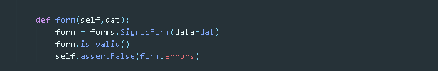

After each test cases the result can be seen with the command python manage.py test which is given below where 6 test were ran but only 1 get success because all the data was valid where other function have invalid data so the error and failure is 5 which shows that the form for signup is good.

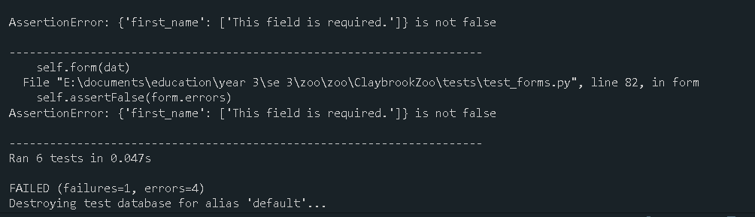

Several test with forms will be done toward where the overall result will be shown at last after completion of all the test cases.

Below is the test result for update form where 4 tests are run and 2 is failure and 2 is success as expected

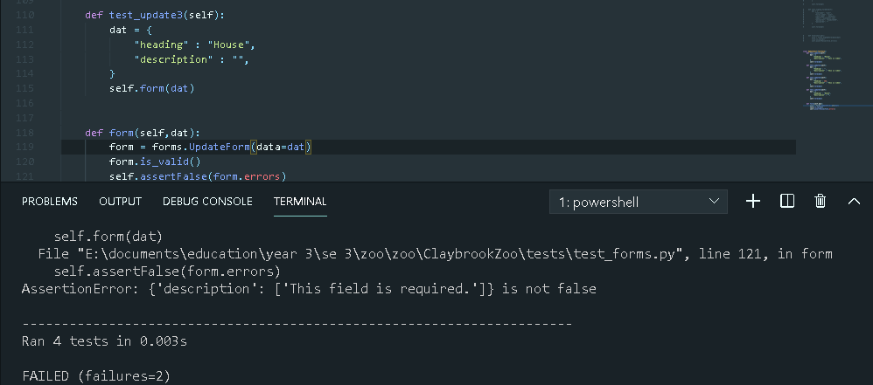

Below is the valid form for sponsorship which shows the test is okay, similarly we can test it with different cases.

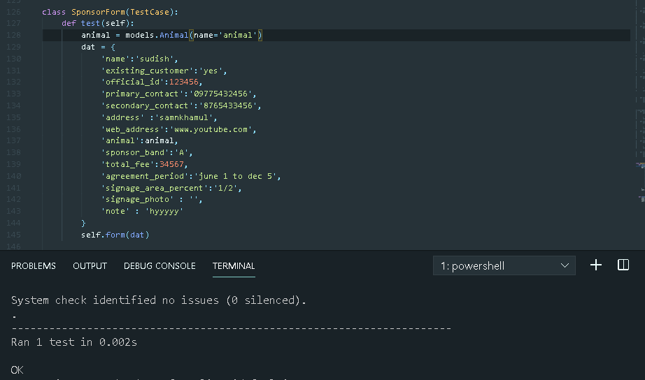So, with the test run of 14 8 are failure and 6 are correct. In this form 6 data are supposed to be optional so that the failure rate is less in compare to others.

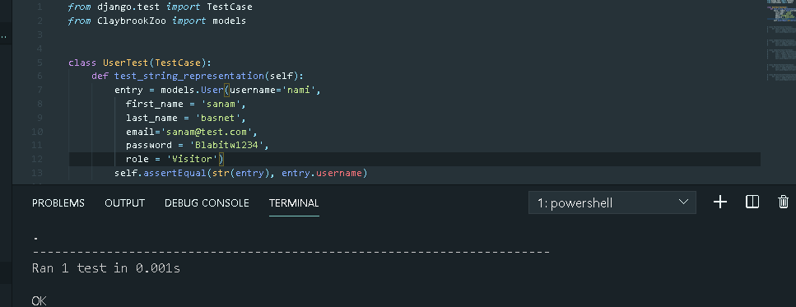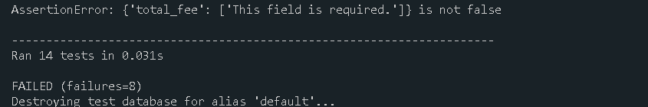The others test will be pointed in the overall test result table. Now after the completion of forms, testing the models with the same technique for unit testing and showing few of them below with results. Below is the test for user model which is successful.

Below is the test for Animal model :

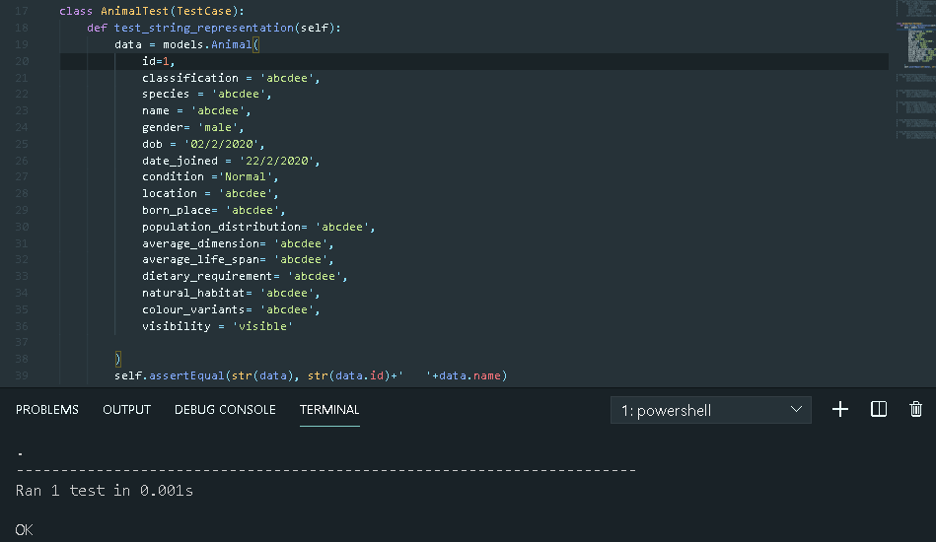

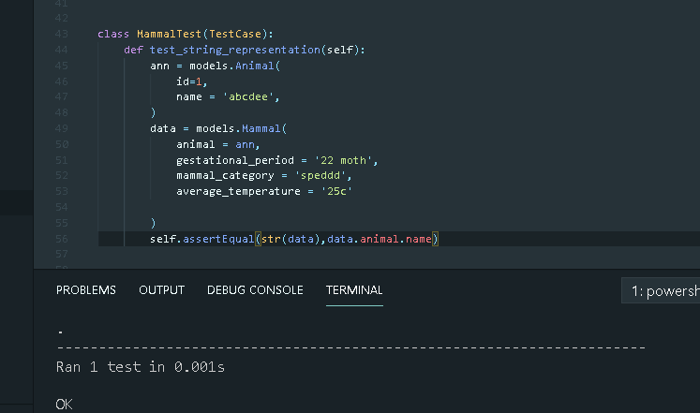Below is the test case for mammal accordingly.

All the test has been made successful where remaining test cases are same done in system test folder but not fully shown here. The overall result of the unit test can be shown below:

|  |  |  |  |  |
| --- | --- | --- | --- | --- |
| Tested unit | Expected result | Actual Result | Time | Remarks |
| forms | 43 tests 30 errors | 43 tests 26 failures and 4 errors | 0.079sec | Successful |
| models | 10 tested 10 oks | 10 tested 10 oks | 0.005sec | Successful |
| views | 26 tested  26 oks | 26 tested 26 oks | 0.038 | Successful |
| Overall | 79 tested  49 oks | 79 tested  49 oks | 0.082sec | Successful |

## 5.2 Black Box Testing

Black-box testing is a software testing method which examines an

application's functionality without interacting into its internal operations or structures.

This test method can be extended to virtually every software test level: process, program, installation, and acceptance. Below are the test outcomes that was carries out after the completion of system unit testing where cases ae the condition of data input either valid or invalid. First test is shown below with each case individually but after some events beside valid case other invalid cases are done in single frame of event.

|  |  |  |
| --- | --- | --- |
| **Action/ Event** | **Expected Output** | **Actual Output** |
| **Login**   * Case1   Username = T  Password = T   * Case2   Username = T  Password = F   * Case3   Username = F  Password = F   * Case4   Username = F  Password = T | * Redirect to homepage * Wrong password * Username or password wrong * Password wrong | * Enter to home page * Error message : Please enter correct username and password * Error message : Please enter correct username and password * Error message : Please enter correct username and password |
| **Signup**   * Case1   Username = T  First name = T  Last name = T  Email =T  Password = T  Password 1 = T   * Case2   Username = F  First name = T  Last name = T  Email =T  Password = T  Password 1= T   * Case3   Username = T  First name = F  Last name = T  Email =T  Password = T  Password 1= T   * Case4   Username = T  First name = T  Last name = F  Email =T  Password = T  Password 1= T   * Case5   Username = T  First name = T  Last name = T  Email = F  Password = T  Password 1= T   * Case4   Username = T  First name = T  Last name = T  Email =T  Password = F  Confirmation Password = T | * Redirect to home page * Username exists * Field empty * Field empty * Email already in use, Incorrect email format * Password not matched | * Redirect to home page * Error message : User with that username already exists. * Error message : Please fill out the field. * Error message : Please fill out the field. * Error message : User with this email already exits , Incorrect mil format * Error message : Two fields did not match , password you used is too common |
| **Update Password**   * Case1   Current Password = T  New Password = T  Confirm Password = T   * Case2   Current Password = F  New Password = T  Confirm Password = T   * Case3   Current Password = T  New Password = T  Confirm Password = F | * success * Old password did not match * Password did not match | * Redirect to home page * Old password was entered incorrectly, enter it again * Error message : Two fields did not match |
| **Booking ticket by visitor**   * Case1   Date = T  Number of entries = T   * Case2   Date = F  Number of entries = T   * Case3   Date = T  Number of entries = F | * success * invalid field * invalid field | * Redirect to payment process * Error message : This field is required * Error message : This field is required |
| **Give Feedback**   * Case1   Description = T   * Case2   Description = F | * Redirect to feedback table * invalid field | * Redirect to feedback table * Error message : This field is required |
| **Sponsor Animal**   * Case1   Name = T  existing_customer = T  official_id = T  primary_contact = T  secondary_contact = T  address = T  web_address = T  animal= T  sponsor_band = T  total_fee = T  agreement_period = T  signage_area_percent = T  signage_photo = T  note = T  agreement = T   * Case2   Name = F  existing_customer = T  official_id = T  primary_contact = T  secondary_contact = T  address = T  web_address = T  animal= T  sponsor_band = T  total_fee = T  agreement_period = T  signage_area_percent = T  signage_photo = T  note = T  agreement = T   * Case3   Name = T  existing_customer = T  official_id = F  primary_contact = T  secondary_contact = T  address = T  web_address = T  animal= T  sponsor_band = T  total_fee = T  agreement_period = T  signage_area_percent = T  signage_photo = T  note = T  agreement = T   * Case4   Name = T  existing_customer = T  official_id = T  primary_contact = F  secondary_contact = T  address = T  web_address = T  animal= T  sponsor_band = T  total_fee = T  agreement_period = T  signage_area_percent = T  signage_photo = T  note = T  agreement = T   * Case5   Name = T  existing_customer = T  official_id = T  primary_contact = T  secondary_contact = T  address = F  web_address = T  animal= T  sponsor_band = T  total_fee = T  agreement_period = T  signage_area_percent = T  signage_photo = T  note = T  agreement = T   * Case6   Name = T  existing_customer = T  official_id = T  primary_contact = T  secondary_contact = T  address = T  web_address = T  animal= F  sponsor_band = T  total_fee = T  agreement_period = T  signage_area_percent = T  signage_photo = T  note = T  agreement = T   * Case7   Name = T  existing_customer = T  official_id = T  primary_contact = T  secondary_contact = T  address = T  web_address = T  animal= T  sponsor_band = T  total_fee = T  agreement_period = T  signage_area_percent = T  signage_photo = T  note = T  agreement = F | * success * invalid field * invalid field * invalid field * invalid field * invalid field * check this first | * Redirect to payment process * Error message : This field is required * Error message : This field is required * Error message : This field is required * Error message : This field is required * Error message : This field is required * Error message : Confirm to continue |
| **Add Animal**   * Case1   Classification = T  species = T  name = T  gender = T  dob = T  date_joined = T  location = T  born_place = T  population_distribution = T  average_dimension = T  average_life_span = T  dietary_requirement = T  natural_habitat = T  colour_variants = T   * Case2   Classification = T  species = F  name = F  gender = T  dob = F  date_joined = F  location = F  born_place = F  population_distribution = F  average_dimension = F  average_life_span = F  dietary_requirement = F  natural_habitat = F  colour_variants = F | * success * invalid field | * Redirect to animal details panel * Error message : Required fields are empty |
| **Watchlist**   * Case1   Animal = T  Condition = T  Location = T  observation_date = T   * Case2   Animal = F  Condition = F  Location = F  observation_date = F | * success * invalid fields | * Redirect to watchlist panel * Error message :Select animal, this field is required |
| **Updates**   * Case1   Heading = T  Description =T   * Case2   Heading = F  Description =F | * success * invalid field | * Redirect to dashboard * Error message : This field is required |

## 5.3 Evaluation

In this section the evaluation of system will be done to get response for the system. This section explains how the solution for the prototype was described, planned, built, tested, and evaluated. Within this section, each individual stage is critically evaluated to assess the efficacy of solution system creation and also review the progress done till software development phase 1 and its ability to meet the minimum requirements offered by the prototype software system solution as well as all the additional functionalities implemented from block 2 to 4.

Two workshop that was provided to get comprehensive information regarding Clay brook Zoo was very effective from which the problem domain of the existing system and then the solution for the new system was taken out. After the completion of workshop 1 and 2, it was finalized about the functionalities to be implement and priorities according to their requirement for the zoo. RAD methodology is effectively used emphasizing JAD. Testing done with python default package with different test cases.

### 5.3.1 Heuristic Evaluation

With the completion of testing for the system, in order to know whether all the requirements were meet or not so that it can be handed over and in case of some lacks then the system implementation will be re implemented accordingly. Here the system performance with functionalities are defined below to evaluate system usability.

**System visibility status**

To ensure users feelings , all the visible solution features for each users are carried in such a way that they get access to each one of them so that they feels the system usable and for making system more flexible and usable , it is design don the motive of making system more simpler with friendly UI and informative navigations or buttons.

**System acceptance with real world**

Considering the real world all the implementation made for this are realist and carried with big research so that there will not be any problem regarding it to near future. Features which belong to real world are given more priority in development and completed with positive results with the respect for all creativity and innovation which were seen during system build.

**Individual freedom and controls**

As this system is built for zoo management so there is certain restriction for users involved in this system where access level is given according to the user’s role and their priority things. For the restricted functionalities, system manage to hide it from the user so that they did not have to query about that. Beside this for each access levels users are given full freedom for their choice of data management regarding them.

**Consistency**

Since system runs with a single server there will not be problem regarding data management as it is designed to be run with the backup sever while one severs downs, so it will not affect the zoo management. The system data are automatically backup where system errors will not cause them anymore.

**Error prevention**

As the system is run by the users and users are normal person so it is obvious that there would be invalid inputs for some cases and for this system each input area are suggested with error messages which will be displayed wrong inputs.

**Recognition and recall**

Since system is built with the motive of simplicity, the designs are almost carried on the basic of normal daily life signs so that user can remember and can recall when he is using the system for next time.

**Flexibility with efficiency**

This system can handle more than 2-3000 users at a same time so there will not be compromise of system performance for each multi-tasking events carried by users. Users can see no difference on using it for multiple purpose although , the system will be used by many users at the same time, but all the functionalities will wisely react.

With the success of satisfying all the mention requirement for this system now it can be handed over the client for use as all the inspection have been done and all the results are good . The system has properly justified every problem domain collected at the beginning of system research with every existing system and the existing business practice.

### 5.3.2 System Pilot Trials

Few volunteers can use system for system workflow evaluation due to absence of stakeholder for this time and the volunteers are given rights to justify the system performance and its feature. Below is the table showing the evaluation outcome. The system review by the developer is also given with the video demo which can be found on the heading with the link.

|  |  |  |
| --- | --- | --- |
| **Volunteers** | **Action** | **Response** |
| Ramesh Jha  (Family Friend) as visitor and sponsor | * Signup * Login * Filter animals * Sponsor animals * Book tickets * Message to zoo * Feedback | Overall, the system is easier to access, and the design is pretty and simple. Signup process is simple .Sponsoring animal is a bit tricky with the selection of animal and the band. Message system for query is good. I have given feedback too. |
| Shyam Kumar Bista  (neighbour) as admin | * Adding animals * Updating user role * Add updates * Check sponsorship | Admin page is good, and the system is also attractive with the animal display view as well as the searching technique with many fields. It is easy to know who sponsored and payment is done or not. Adding updates seems helpful. |
| Daniel Limbu  (Friend) as manager | * Check users * Add updates * Reply messages * Highlight feedback | I can easily search users in the system though I cannot update or delete them. Messages from visitors can be seen which is great. Interesting part is highlighting feedback and it automatically displays at home page . |

# 6 Conclusion

Overall, the prototype software system solution which is develop for the Clay brook zoo meets and exceeds the minimum requirements which were specified by the client which was given in brief and extra functionalities were implemented with the overview of workshop 2. Testing for the solution system is done with unit testing and black box testing with the use of coverage and python test .Methodology which was use for the development of prototype was using the RAD (Rapid Application Development) emphasizing the Collaborative Application Design which is JAD for elicitation of workshop tasks during the initial development phases.

The prototype system development was split into several development blocks with comparison to sprint development cycles considering software development block 1 fully justified with extra functionalities explained. To explore the system practically individually can go through the README.md file in root directory. All the activities from the workshops were found very helpful with the suitable methodology for development covering impact full requirement engineering which is the base for system survival whenever system runs. The prototype is finalized after the completion of development and done proper testing with system evaluation so that it can be handed over to client.

# 7 References

1. En.wikipedia.org. 2020. *Agile Software Development*. [online] Available at: <https://en.wikipedia.org/wiki/Agile_software_development> [Accessed 1 April 2020].
2. Zoo.sandiegozoo.org. 2020. *San Diego Zoo® Official Site | Voted #1 Zoo In The World*. [online] Available at: <https://zoo.sandiegozoo.org/> [Accessed 2 April 2020].
3. Umsl.edu. (2019). *Systems Development � JAD and RAD*. [online] Available at: http://www.umsl.edu/~sauterv/analysis/488_f02_papers/JADandRAD.html. [Accessed 11 March 2020].
4. Zoological Society of London (ZSL). 2020. *ZSL London Zoo*. [online] Available at: <https://www.zsl.org/zsl-london-zoo> [Accessed 2 April 2020].
5. Stlzoo.org. 2020. *Home | Saint Louis Zoo*. [online] Available at: <https://www.stlzoo.org/> [Accessed 2 April 2020].
6. Legislation.gov.uk. (2019). *Computer Misuse Act 1990*. [online] Available at: http://www.legislation.gov.uk/ukpga/1990/18/crossheading/computer-misuse-offences [Accessed 4 April. 2019].
7. GOV.UK. (2019). *Data protection*. [online] Available at: https://www.gov.uk/data-protection [Accessed 4 April. 2019].
8. Service, U. (2019). *UK Copyright Law. Copyright, Designs and Patents Act 1988*. [online] Copyrightservice.co.uk. Available at: https://www.copyrightservice.co.uk/copyright/uk_law_summary [Accessed 4 April. 2019].
9. En.wikipedia.org. 2020. *Black-Box Testing*. [online] Available at: <https://en.wikipedia.org/wiki/Black-box_testing> [Accessed 14 April 2020].
10. Python, R. (n.d.). *Django Tutorials – Real Python*. [online] realpython.com. Available at: https://realpython.com/tutorials/django/ [Accessed 16 April 2020].
11. Daud, N.M.N., Bakar, N.A.A.A. and Rusli, H.M. (2010). Implementing rapid application development (RAD) methodology in developing practical training application system. *2010 International Symposium on Information Technology*. [online] Available at: https://ieeexplore.ieee.org/document/5561634 [Accessed 14 March 2019].
12. Percival, H. (2014). *Test-Driven Development with Python: Obey the Testing Goat: Using Django, Selenium, and JavaScript*. [online] *Google Books*. “O’Reilly Media, Inc.” Available at: https://books.google.com.np/books?hl=en&lr=&id=fTLJAwAAQBAJ&oi=fnd&pg=PR6&dq=dajngo+apps&ots=A5h3az8tXU&sig=NyoVpsu6ENhIN6l_uxF_eS-wGnE&redir_esc=y#v=onepage&q=dajngo%20apps&f=false [Accessed 16 April 2020].
13. Simple is Better Than Complex. (2016). *How to Work With AJAX Request With Django*. [online] Available at: https://simpleisbetterthancomplex.com/tutorial/2016/08/29/how-to-work-with-ajax-request-with-django.html [Accessed 25 April 2020].
14. www.agiliq.com. (n.d.). *Using Paypal with Django*. [online] Available at: https://www.agiliq.com/blog/2008/11/using-paypal-with-django/ [Accessed 25 April 2020].
15. www.django-rest-framework.org. (n.d.). *Serializers - Django REST framework*. [online] Available at: <https://www.django-rest-framework.org/api-guide/serializers/>. [Accessed 25 April 2020].
16. www.pluralsight.com. (n.d.). *How to Work with AJAX in Django | Pluralsight*. [online] Available at: https://www.pluralsight.com/guides/work-with-ajax-django [Accessed 25 April 2020].
17. Django Stars Blog. (2019). *Using the Django REST Framework to Develop APIs*. [online] Available at: https://djangostars.com/blog/rest-apis-django-development/ [Accessed 26 April 2020].

# 8 Appendix

## 8.1 Wireframes

The wireframes which were confirmed during the workshop second showing some functionality for the initial development so that it will justify during the implementation of system to make user interface ease . Below are the wireframes with the functionality or design title below the images. The content will be changed where header and footer will be same depending upon the authentication of user .

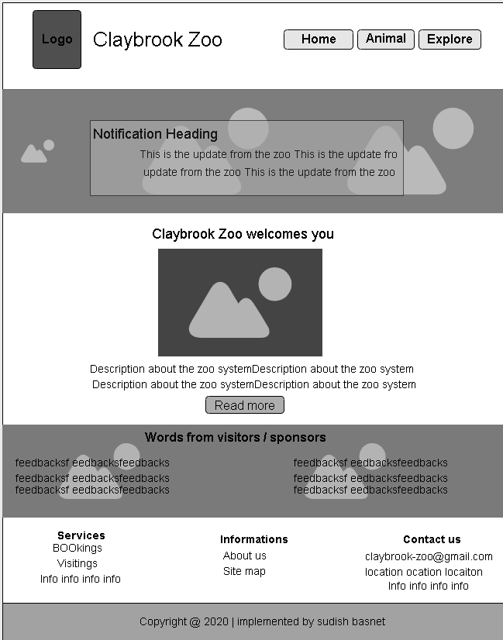

Figure 19 : Homepage Wireframe

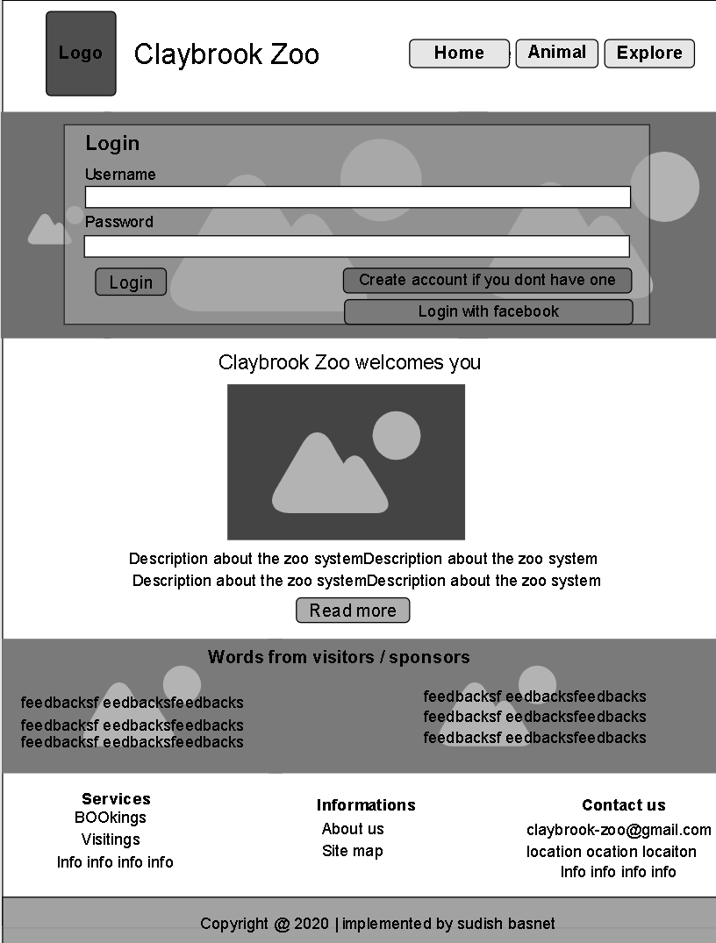

Figure 20 : Login Wireframe

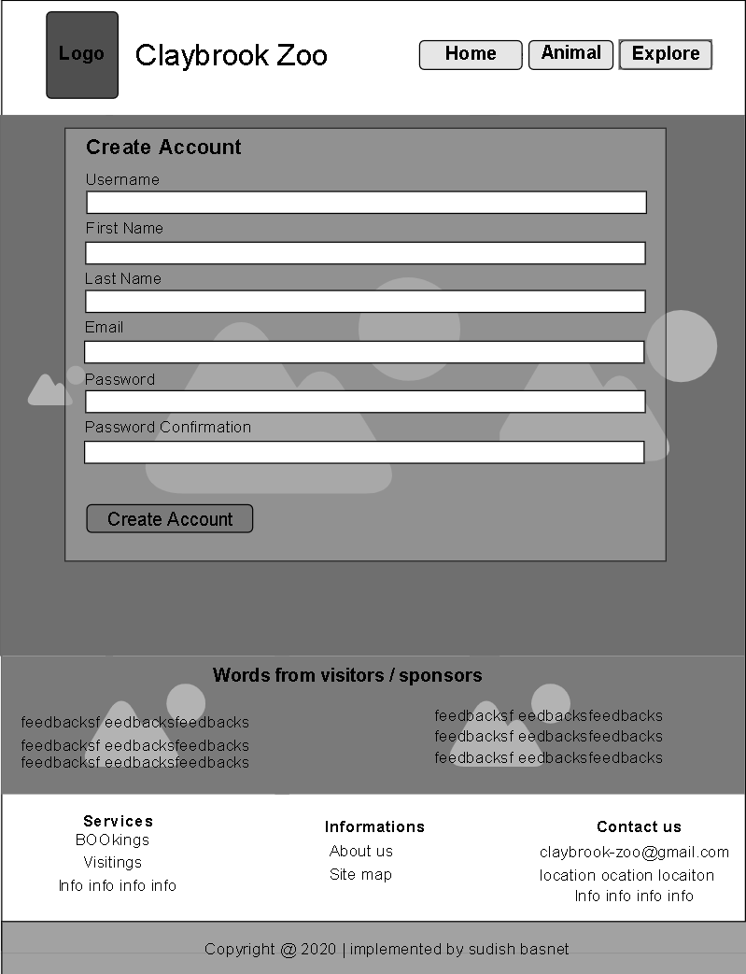

Figure 21 : Signup page wireframe

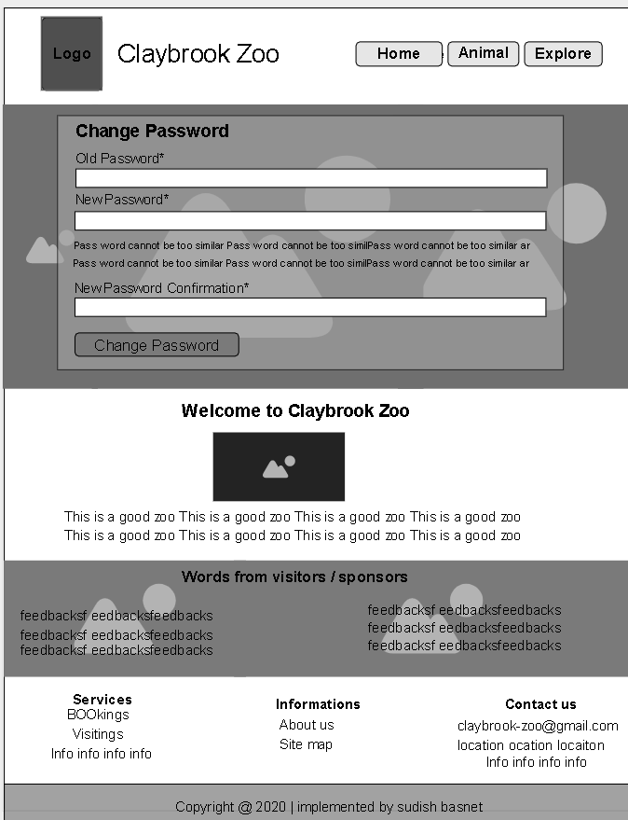

Figure 22 : Password change page wireframe

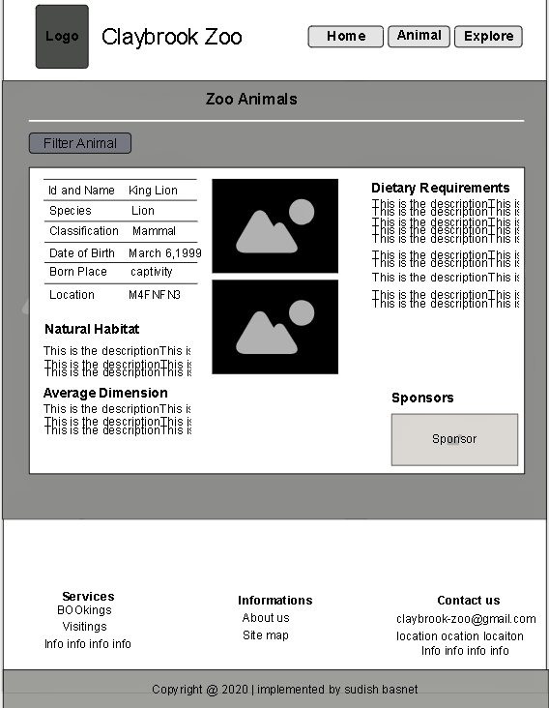

Figure 23 : Animal Information wireframe

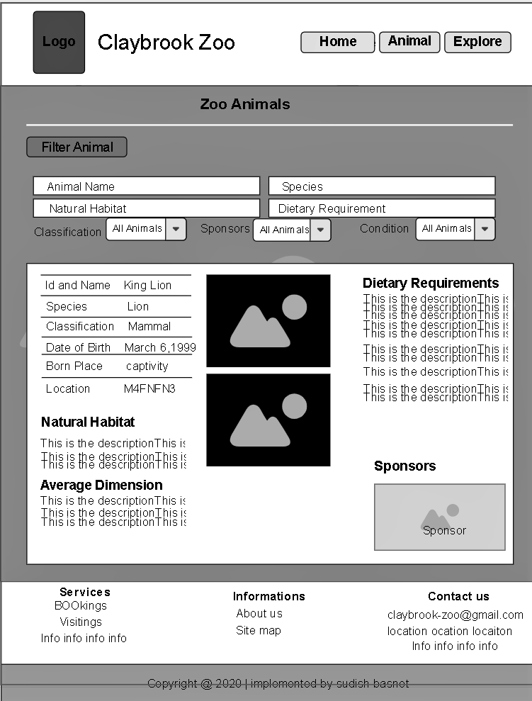

Figure 24 : Animal filter wireframe

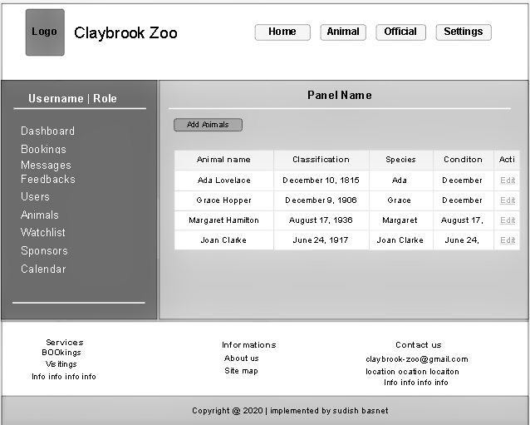

Figure 25 : Admin panel wireframe

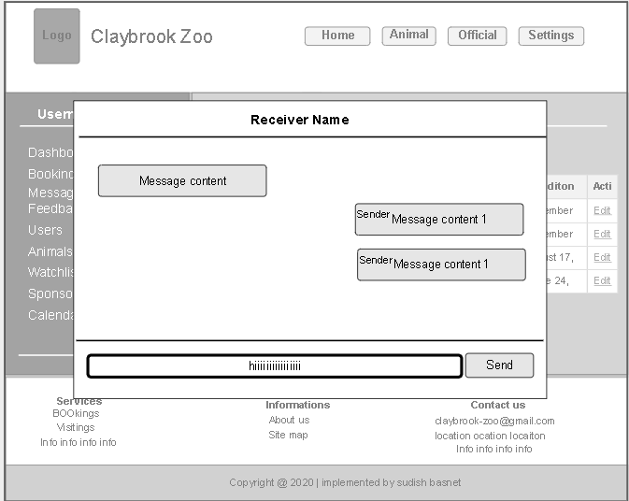

Figure 26 : Admin message panel wireframe

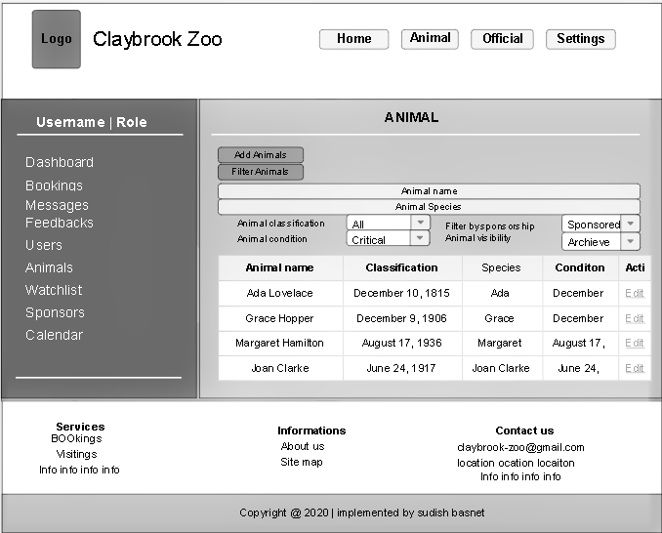

Figure 27 : Admin animal panel wireframe

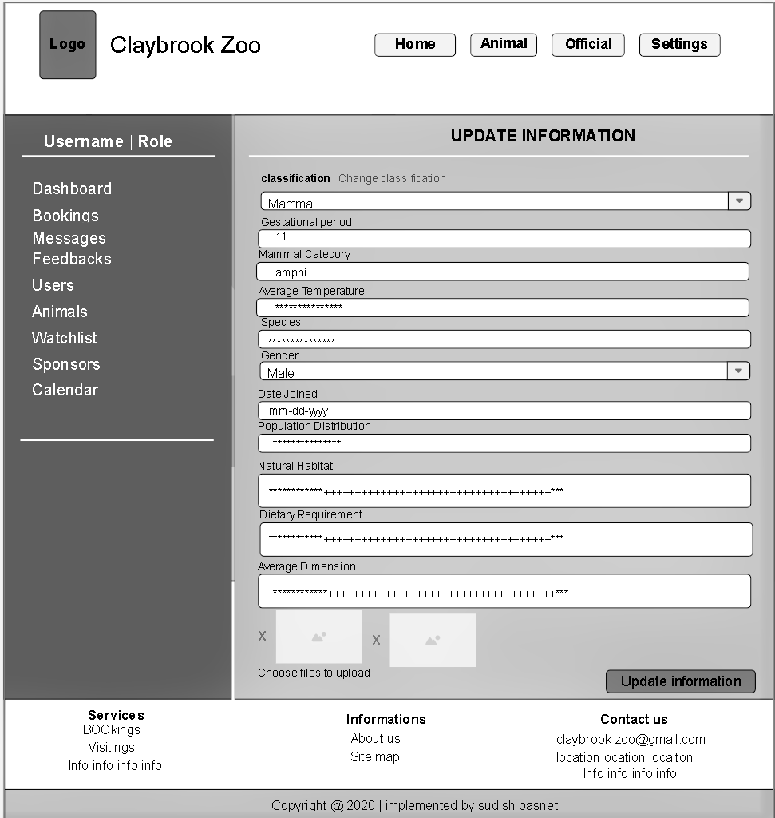

Figure 28 : Admin Animal update panel wireframe

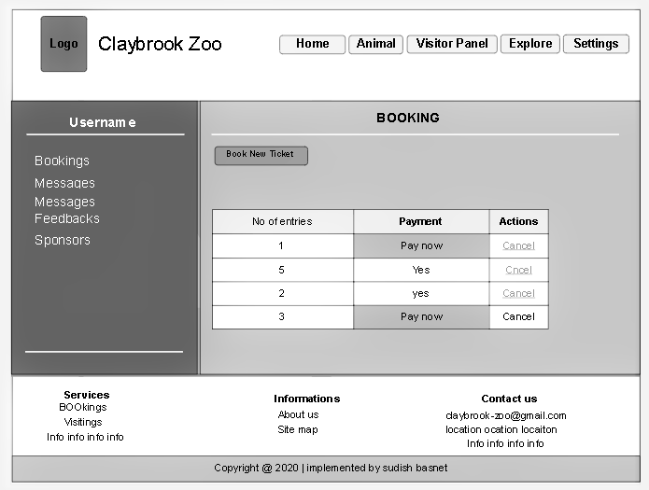

Figure 29 : Visitor panel wireframe

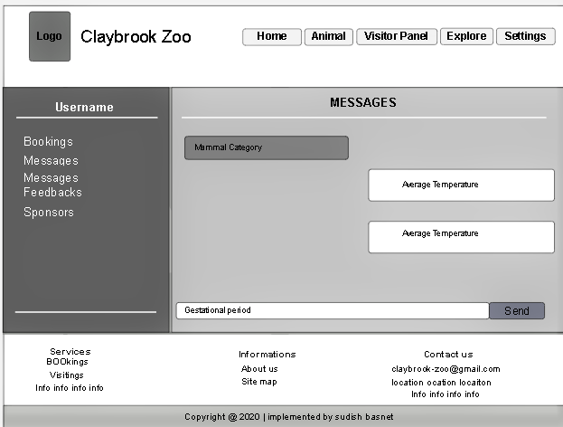

Figure 30 : Visitor message panel wireframe

## 8.2 Mock-ups

Mock-ups are the implemented wireframes which gives the look as of real system. The content panel is the mock-up will be different depending upon the panel where the user is, and the header and footer will be same beside the navigation where it depends upon user role who is authenticate. Below are the mock-ups for the solution system which was shown to stakeholders during workshop 2 for problem domain solution and accepted by them. To give the more real view, real time images are used to that viewer can get proper justification about the system and will be used during prototype implementation

.

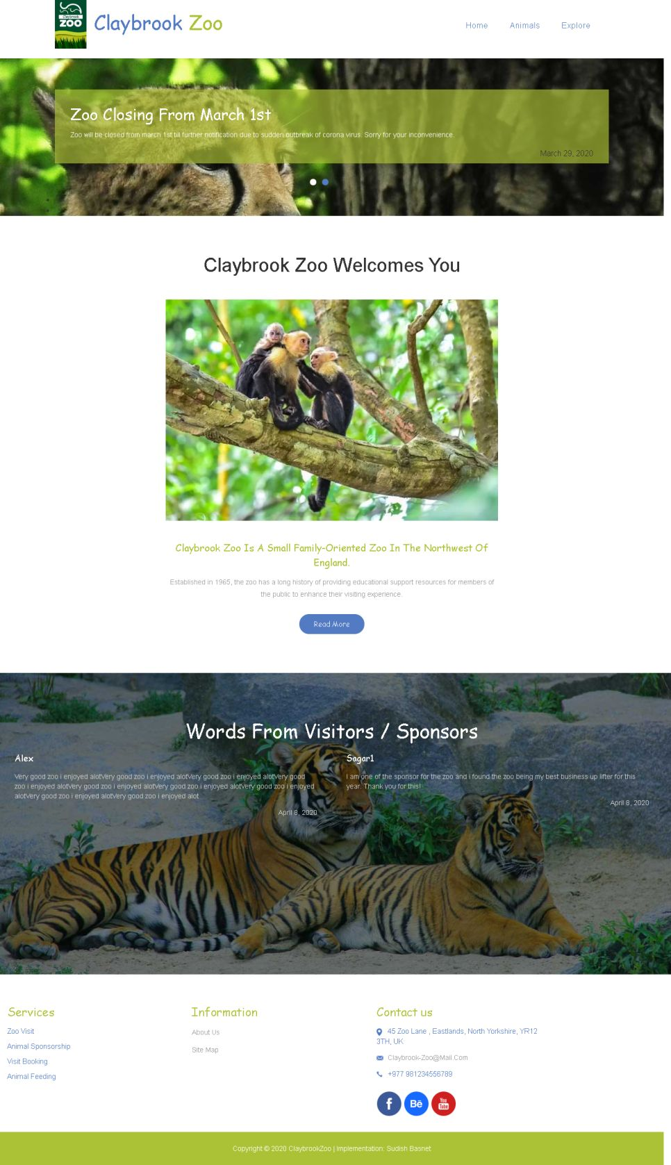

Figure 31 : Zoo homepage mock-up

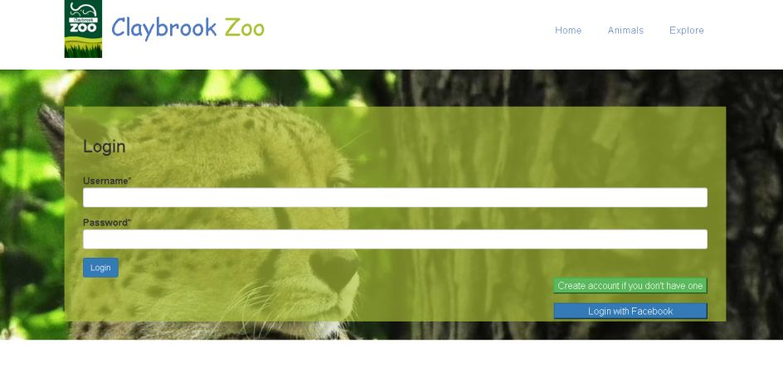Figure 32 : Login panel mockup

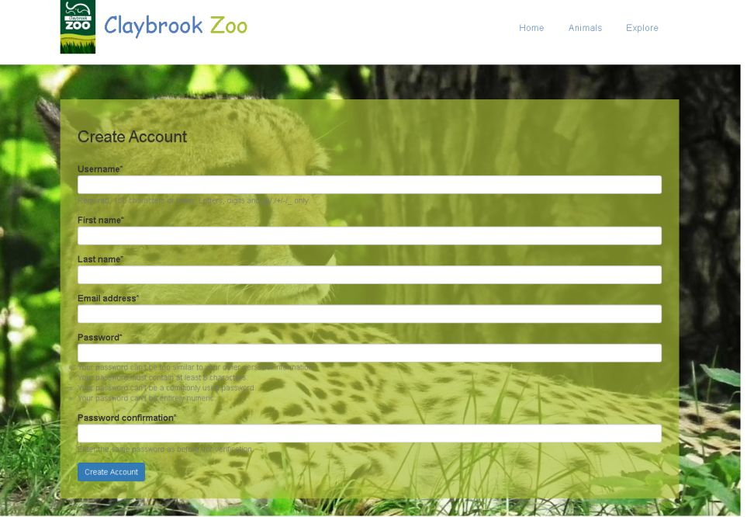

Figure 33 : Signup page mockups

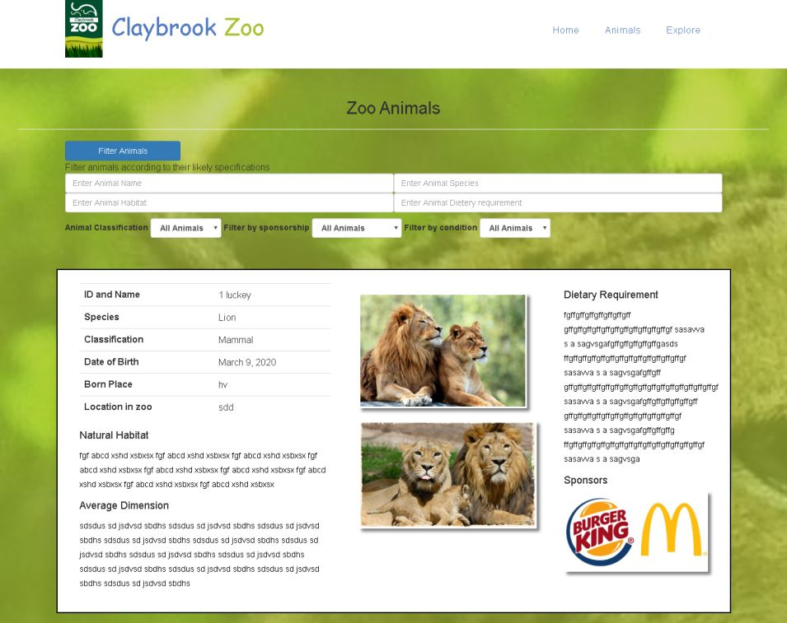

Figure 34 : Animal information mockup

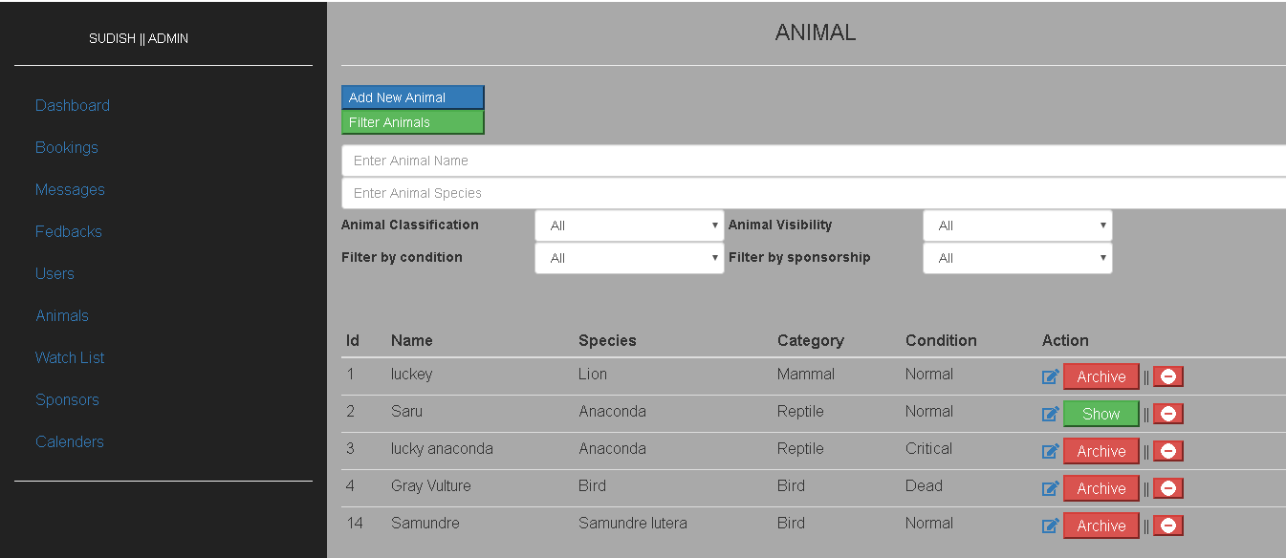

Figure 35 : Admin animal panel mockup

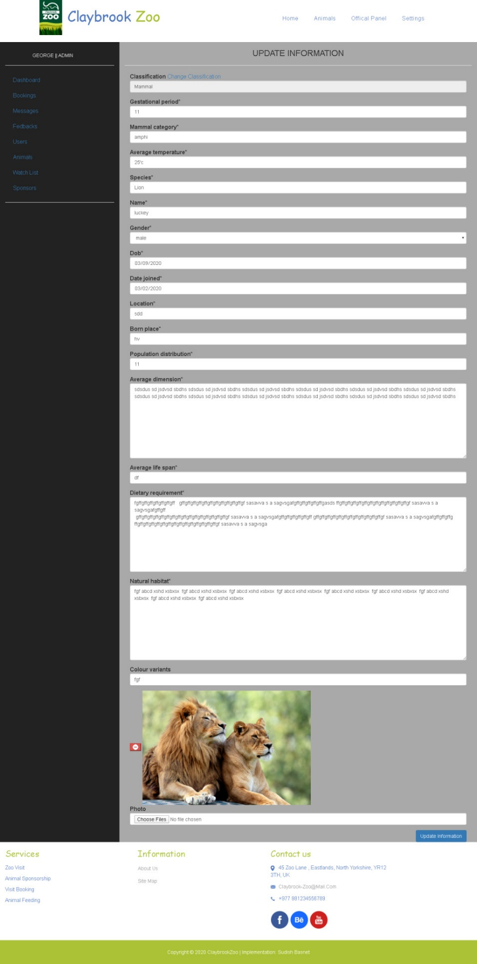

Figure 36 : Admin Update Animal Mockup

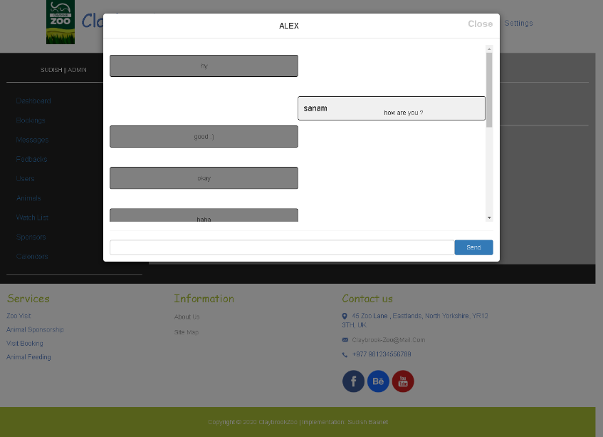

Figure 37 : Admin message panel mockup

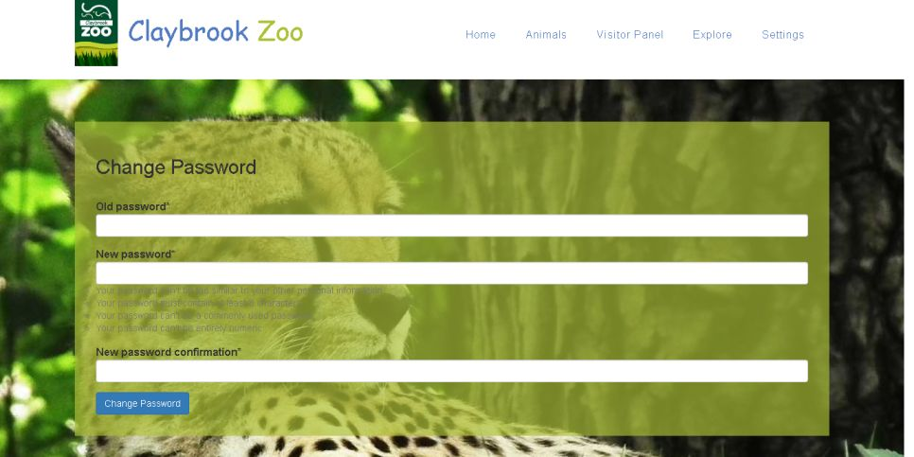

Figure 38 : Change password mockup

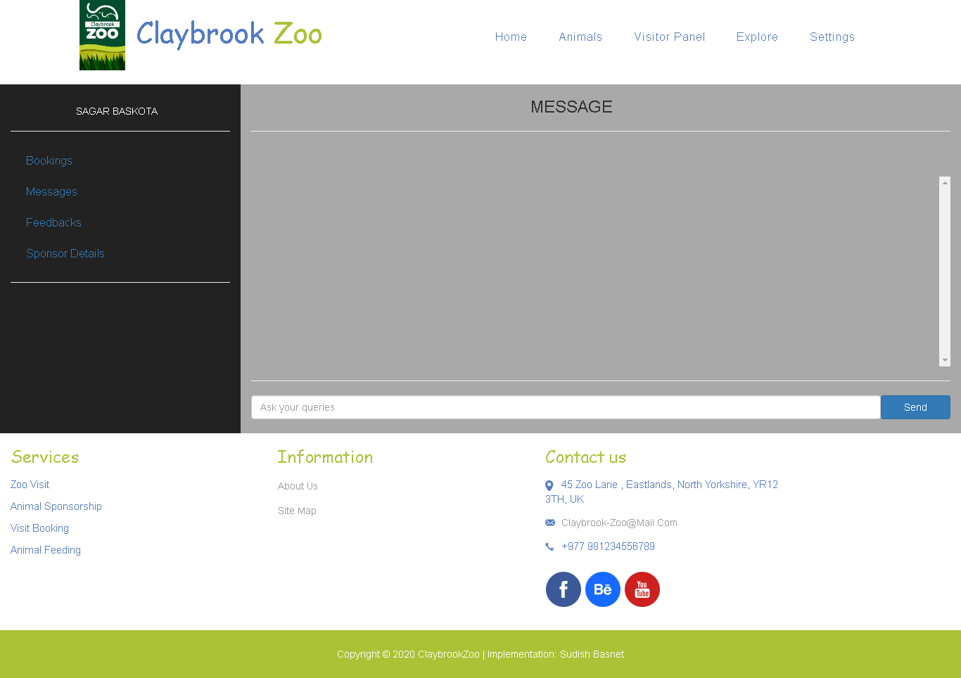

Figure 39 : Visitor message panel

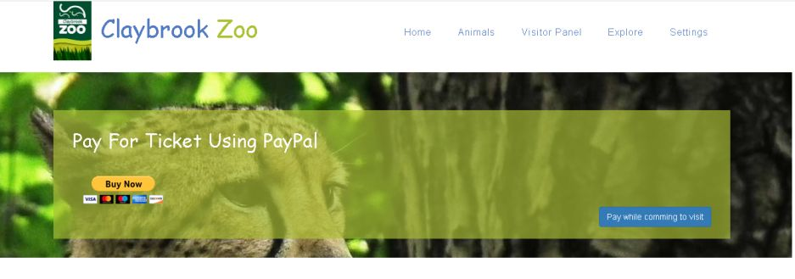

Figure 40 : Payment process mockup

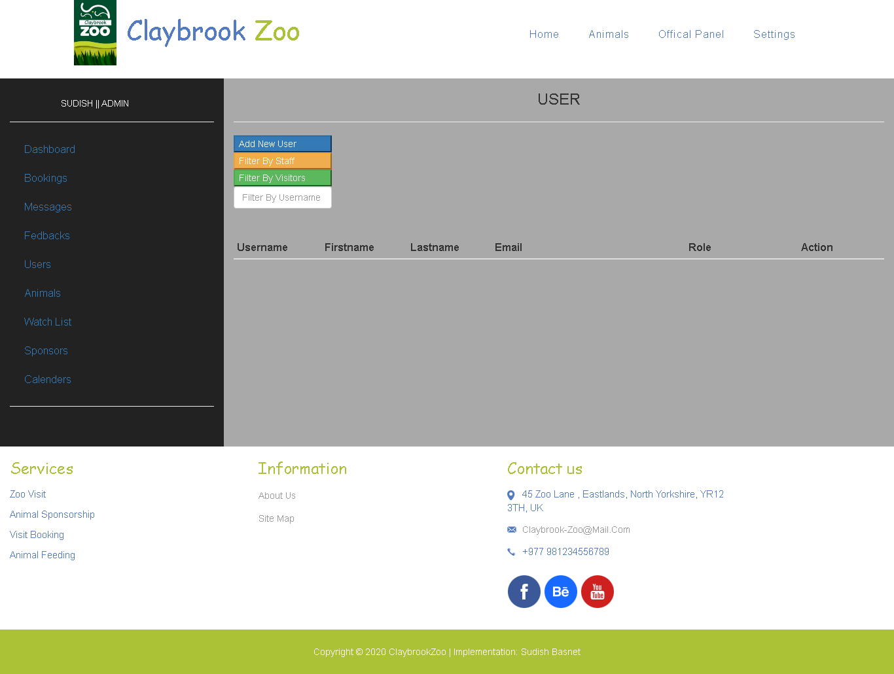

Figure 41 : Admin user list panel mockup

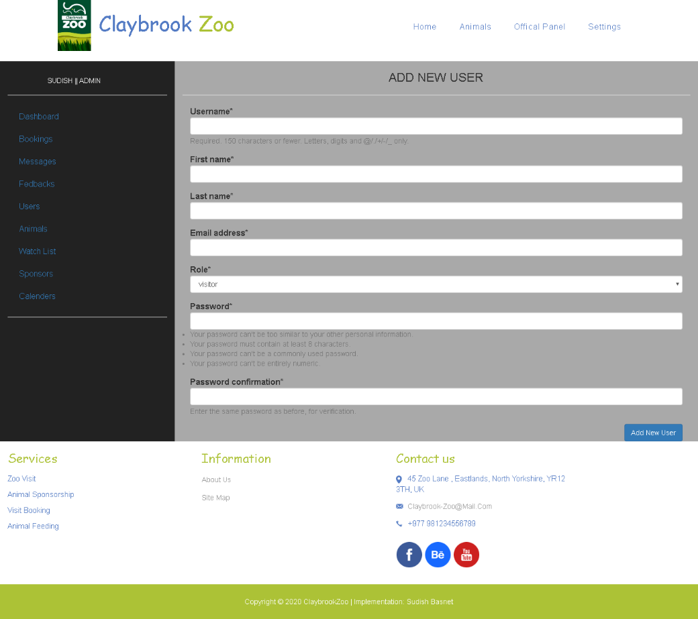

Figure 42 : Admin user addition form mockup

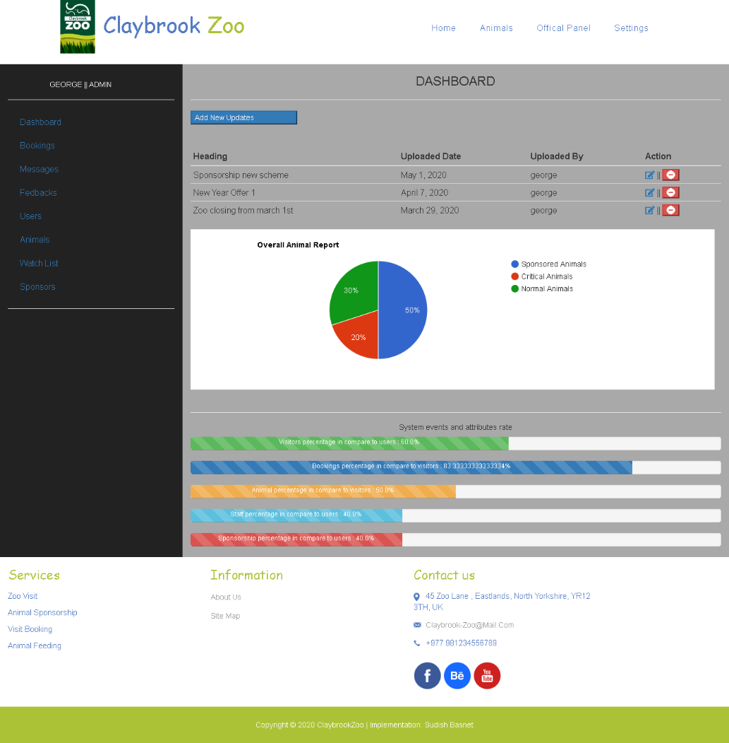

Figure 43 : Admin dashboard panel mockup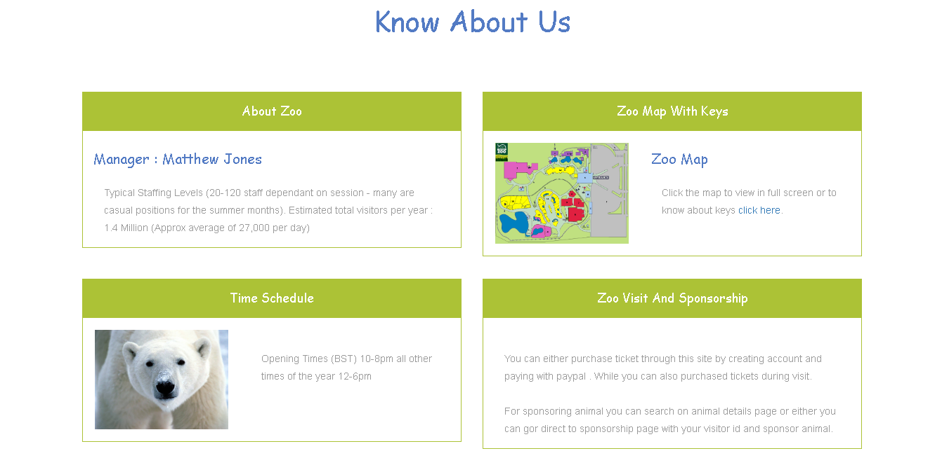

Figure 44 : about us page mockup

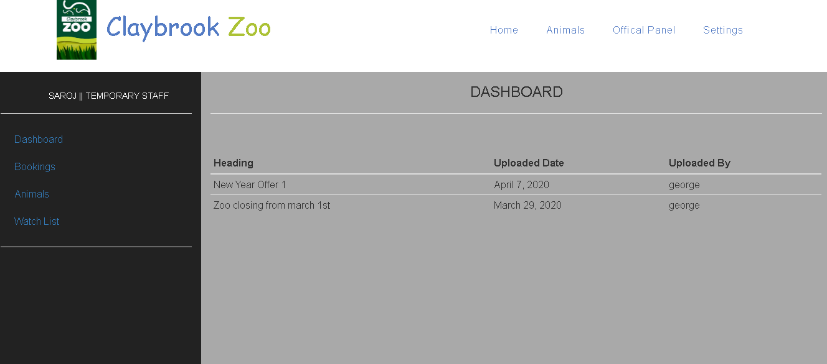

Figure 45 : Temporary staff dashboard mockup

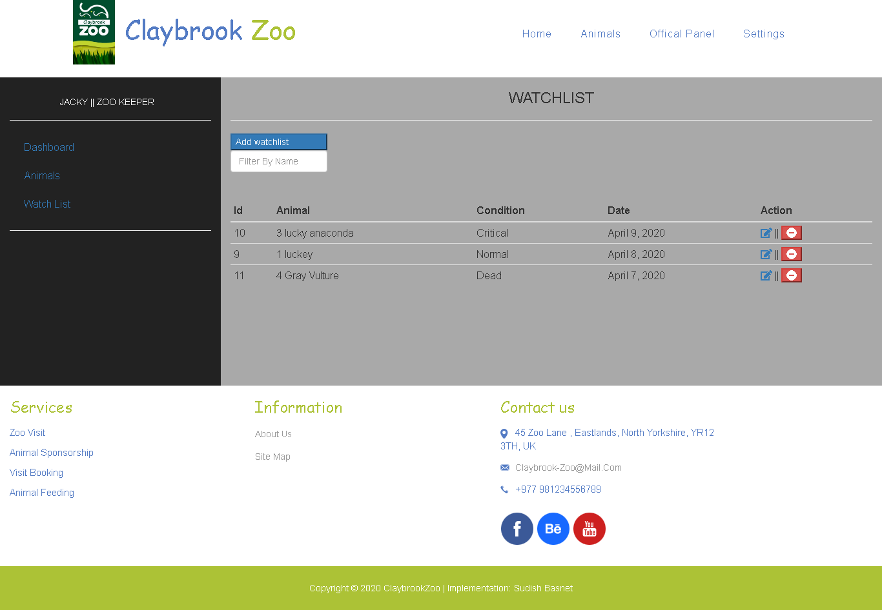

Figure 46 : Zookeeper dashboard mockup

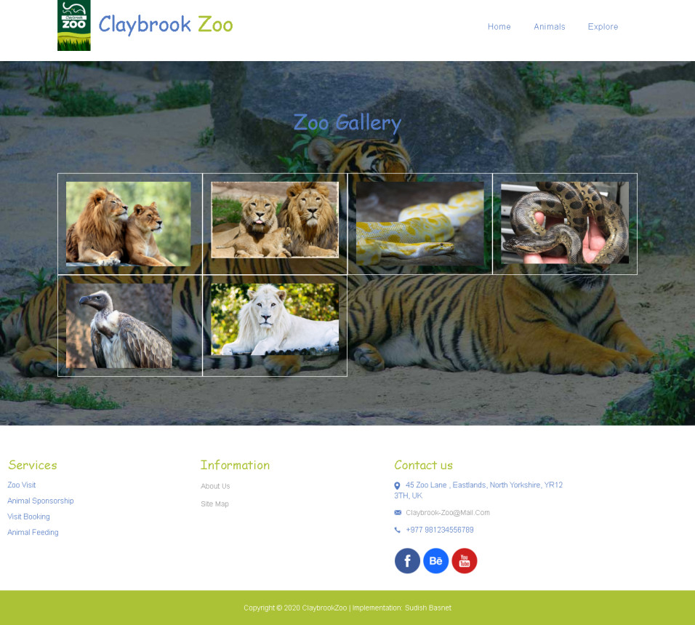

Figure 47 : Zoo Gallery Mock-ups

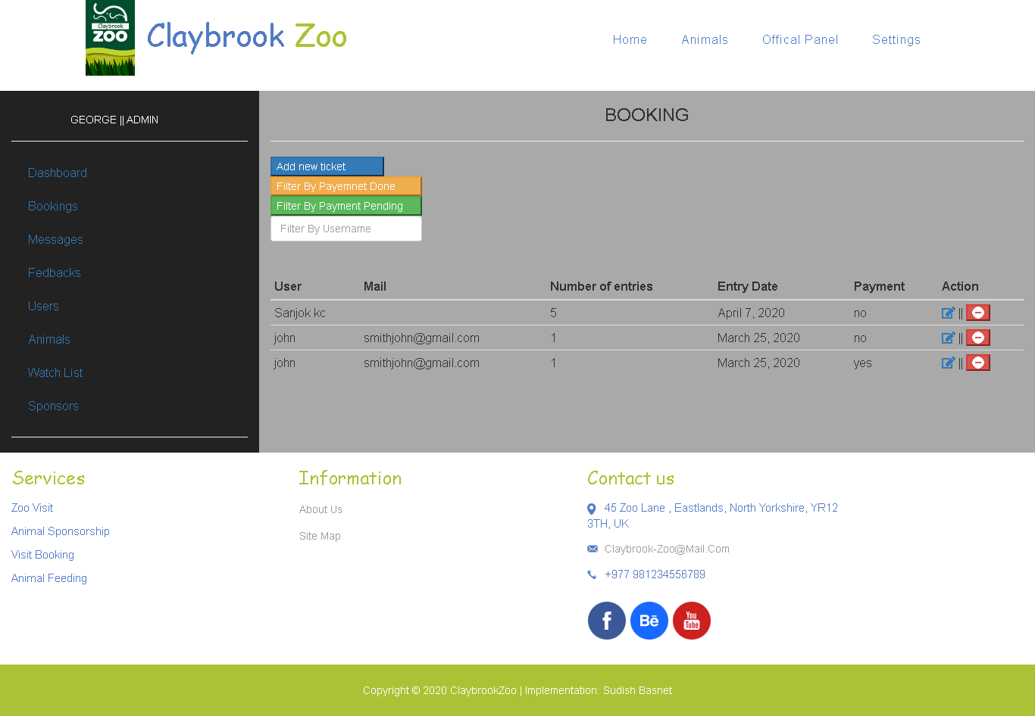

Figure 48 : Booking panel for admin

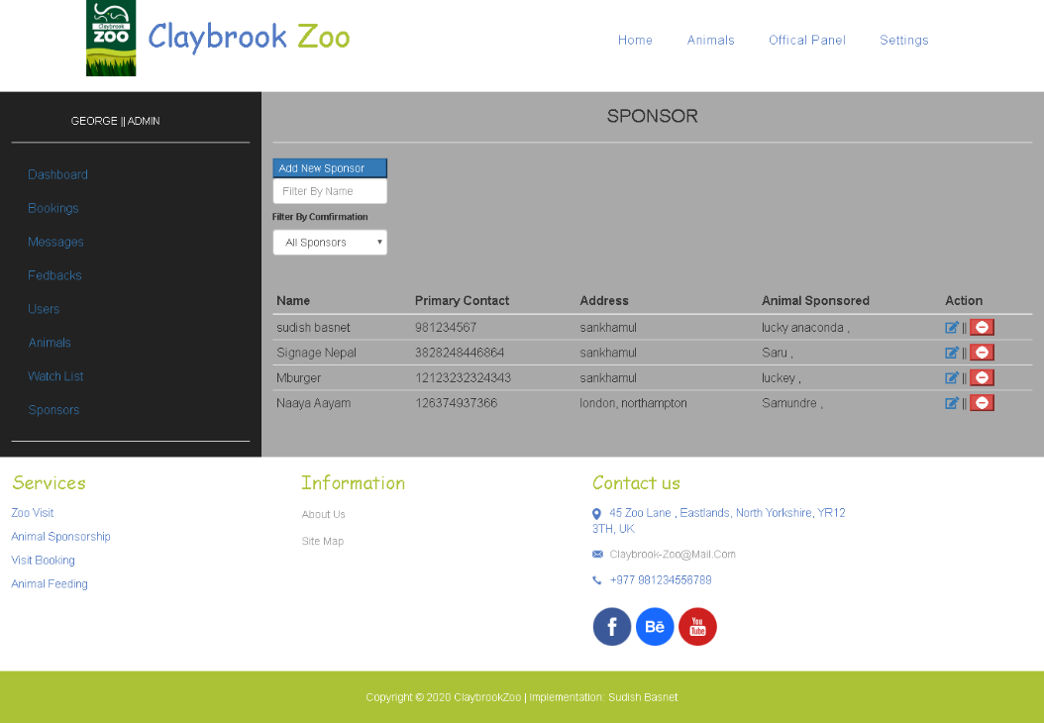

Figure 49 : Sponsors panel for admin

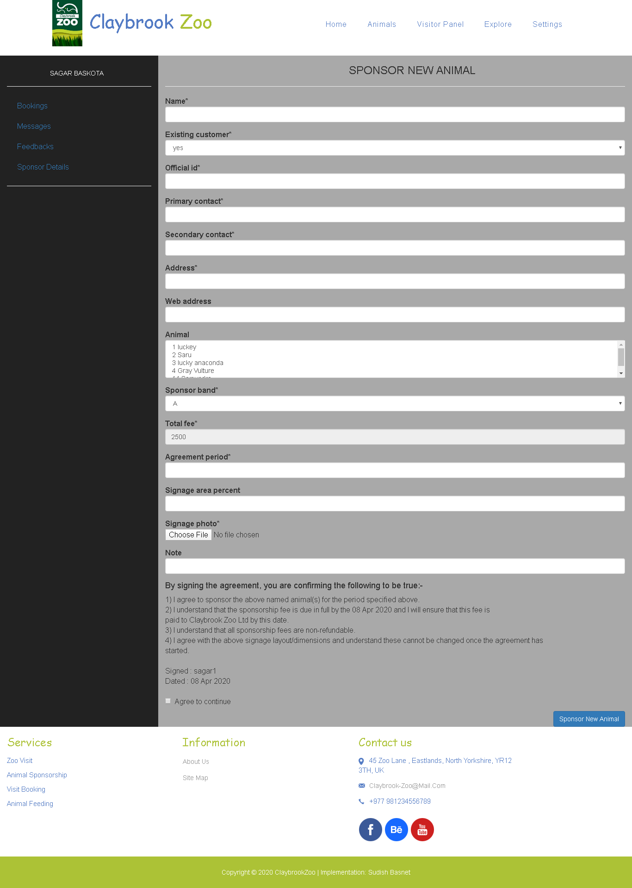

Figure 50 : Visitor sponsorship panel mockup

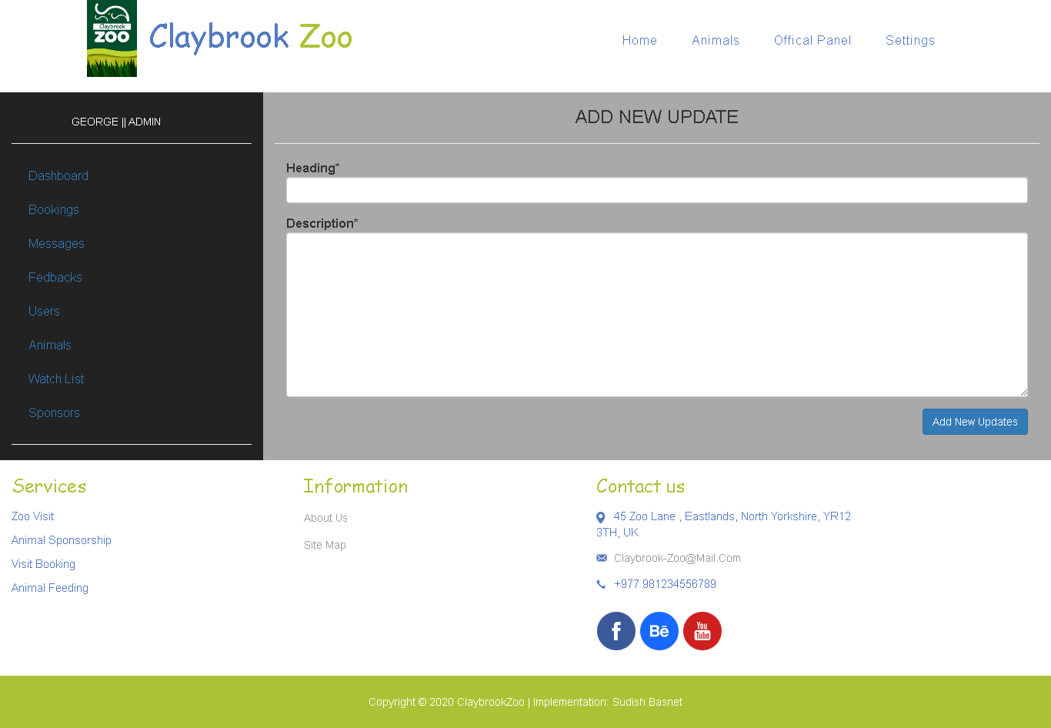

Figure 51 : Zoo Updates form mockup

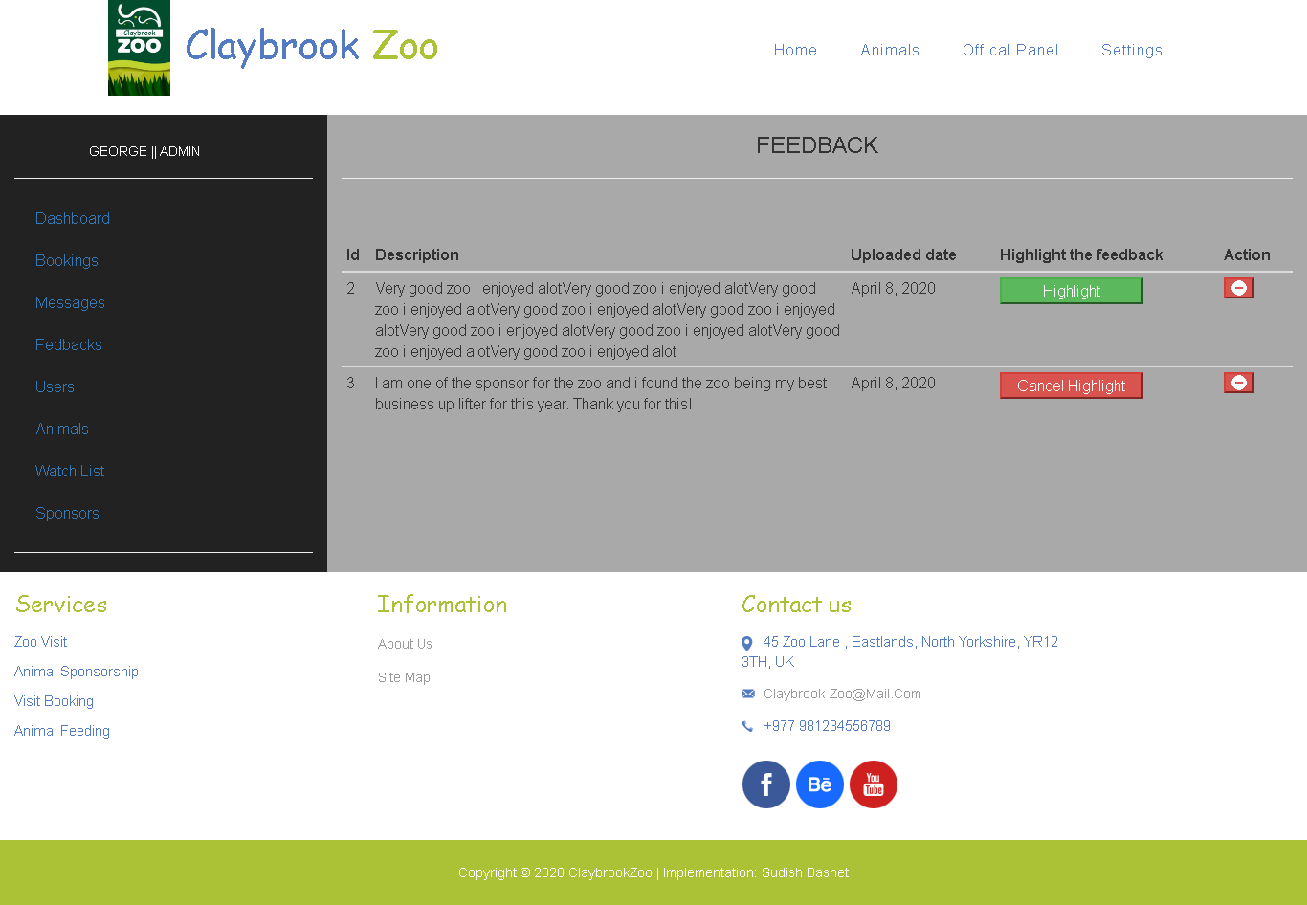

Figure 52 : Zoo feedbacks panel mockup

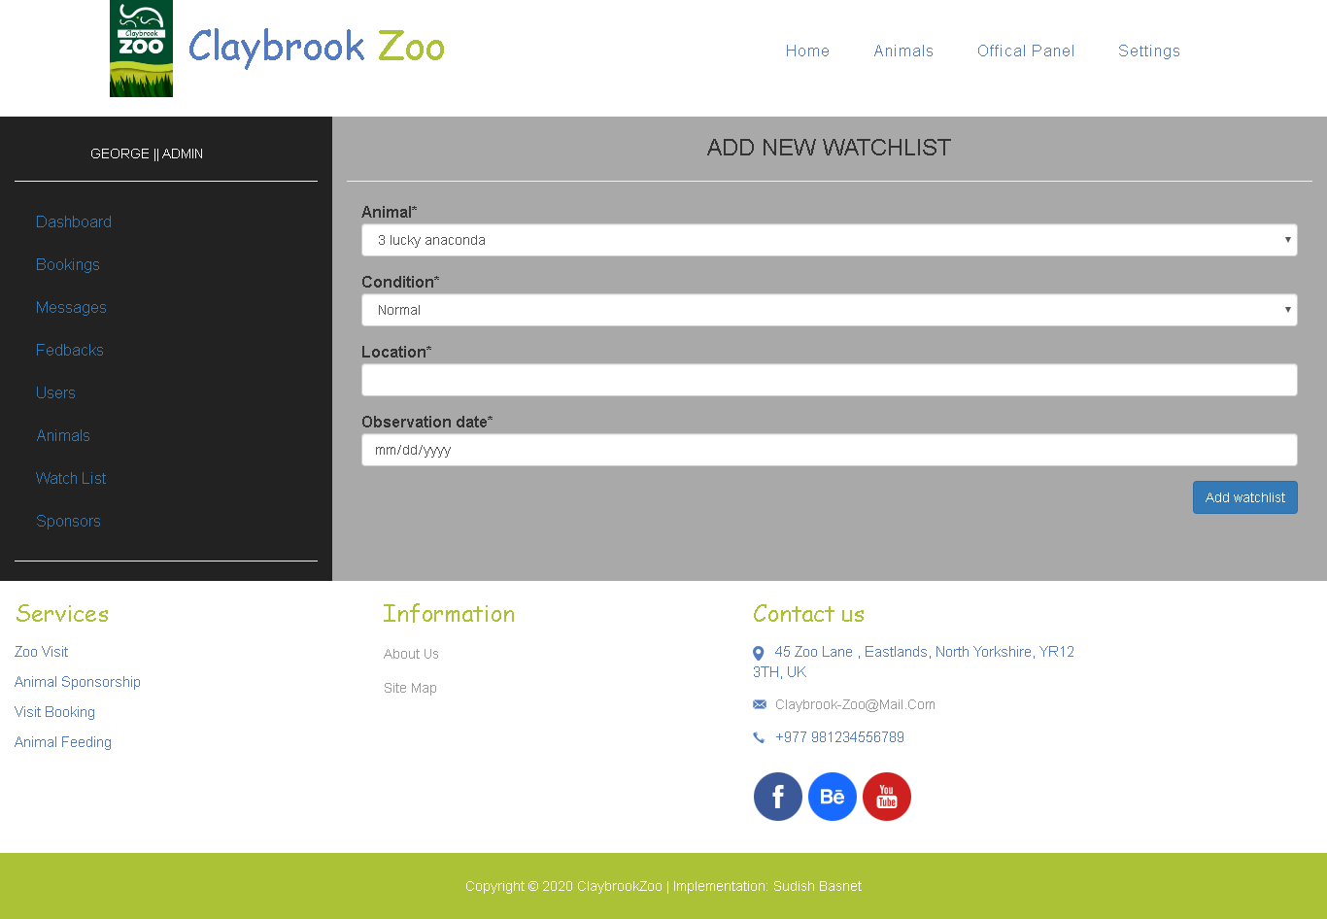

Figure 53 : Animal Watch list form

## 8.3 Project Gantt Chart

For the system development and report writing of system time have been schedule according to which the system should be complete as well as report. The complete work completed in expected time can be considered as efficacy in deep requirement engineering. In the below Gantt chart, the green block is the complete work where the number in the block is the time acquired for work to be completed.

